DSDM Project: UA, UCSD, LU
Draft Seismic Design Methodology Document for Precast Concrete Diaphragms
Attachment to the Final Report to the Charles Pankow Foundation from The University of Arizona for Revised CPF 08-07 Grant “Development and Design of Untopped Precast Concrete Diaphragm Systems for High Seismic Zones”,
Robert B. Fleischman
6/6/2009


This draft seismic design methodology document has been reviewed by a subgroup of the DSDM TG including Tom D’Arcy, Neil Hawkins, S.K. Ghosh and Susie Nakaki. The final seismic design methodology document will be reviewed by the entire DSDM Task Group including, in addition to the members already listed, Doug Sutton, Dave Dieter, Joe Maffei, Ned Cleland, Harry Gleich , Roger Becker, Chuck Magnesio and Paul Johal (See Appendix 1).

Seismic Design Methodology for Precast Concrete Floor Diaphragms

Developed by the DSDM Consortium
Robert B. Fleischman, Principal Investigator

DSDM Research Sponsors
The Precast/Prestressed Concrete Institute (PCI)
The Charles Pankow Foundation (CPF)
The National Science Foundation (NSF)
The George E. Brown Network for Earthquake Engineering Simulation (NEES)

PART A: Precast Diaphragm Seismic Design Procedure .……………...……...….….……......…3
PART B: Precast Concrete Diaphragm Reinforcement Classification…….……...…….….........11
PART C: Analysis Techniques for Diaphragm Design……...………………………..…........…14
PART D: Diaphragm Design Charts and Examples.…..…...…………………………........……21
Commentary.………………..……………………...…….……............................................…...22
Appendices .……………………...…….………………......…………………………………….31

PART A: Seismic Design Procedure for Precast Concrete Floor Diaphragms

A.1 Precast Diaphragm Seismic Design Procedure

Step 1: From the planned structural layout, determine maximum effective floor span and aspect ratio between primary (vertical-plane) elements of the LFRS as follows:
  - Determine length between primary vertical elements of the LFRS, L_{cl}
      - Perform this calculation for each unique diaphragm span
      - Perform this selection for each floor with a different layout
  - Calculate effective span L_{eff} for each diaphragm span:
L_{eff} = α L_{cl}
where the effective span factor α is given in Table A-1.
  - Select maximum effective span for the structure L_{eff,max}
  - Determine effective aspect ratio in plan, AR for each diaphragm span:
AR = L_{eff} /d
where d is the floor diaphragm depth associated with each L_{eff}
  - Determine the Diaphragm Configuration Designation (DCD) using Table A-2.
      - Perform this calculation for each unique diaphragm span in the structure

Table A-1. Diaphragm Effective Span Factor and Moment Coefficients.
Span Boundary Condition | α | C⁺_{m} / C⁻_{m} | C_{Δf} / C_{Δv}
Perimeter | 1.0 | 0.125 / ----- | 0.156 / 0.125
Interior | 0.7 | 0.042 / -0.083 | 0.312 / 0.125
Overhang | 2.0 | --- / 0.500 | 1.500 / 0.500

Table A-2. Diaphragm Configuration Designation (DCD).
AR | Designation
AR<1.5 | Squat (SQT)
1.5<AR<3.0 | Intermediate (INT)
AR>3.0 | Long (LNG)

Step 2: Estimate the diaphragm-influenced fundamental period T_{a,d} by modifying the approximate structural period T_{a} = C_{t}h_{n}^{x} as calculated in (Eq. 9.5.5.3.2-1) of 2006 IBC:
T_{a,d} = κ_{a} T_{a} (1)
where the diaphragm flexibility factor κ_{a} is approximated here as:
κ_{a} = 1 + C₁ (L_{eff,max}/h_{n})² ≤ 2.0
where C₁ is an LFRS coefficient given in Table A-3, h_{n} is the height of the structure.
      - For Equation 1, κ_{a} can be taken conservatively as unity.
      - T_{a,d} can alternatively be estimated through structural analysis using approximate moduli in Table A-8 and the procedures of Sec. C.1 or C.2.
Table A-3. LFRS coefficient.
LFRS Type | C₁ | C_{LF}
Shear Wall | 0.020 | 1.00
Braced Frame | 0.015 | 0.85
Moment Frame | 0.010 | 0.70

Step 3: Determine the baseline seismic force coefficients as per 2006 IBC included:
- Determine design spectral acceleration from hazard maps and SDC from seismic use groups as per IBC Section 9.4.
- Calculate the controlling seismic response coefficient C_{s} as determined in accordance with IBC Section 9.5.5.2.1. Use T_{a,d} for Eqn. 9.5.5.2.1-2.
- Calculate the maximum vertical distribution factor C_{vx,max} (typically at the roof) in accordance with equation Eq. 9.5.5.4-2 for C_{vx} as per IBC Section 9.5.5.4.
- Calculate Baseline Diaphragm Acceleration, C_{dia}
C_{dia} = C_{vx,max} C_{s}
- Calculate Baseline Diaphragm Force at each level x, F_{dia,x}
F_{dia,x} = C_{dia} w_{x}
where w_{x} = the portion of the total structure weight (W) located at Level x

Step 4: Select Diaphragm Design Option and Diaphragm Detail Classification
Approach A: No Diaphragm Reinforcement Preference
- Select a desired and appropriate Diaphragm Design Option (EDO, BDO, RDO) based on SDC and DCD using Table A-4.
- Select an appropriate Diaphragm Detail Classification (LDE, MDE, HDE) for the primary reinforcement based on the Diaphragm Design Option using Table A-5.
      - Shaded options in Table A-4 and A-5 are not allowed
      - Empty boxes in Table A-4 and A-5 are considered overdesigns.
- Select a set of appropriate prequalified connections within the selected Diaphragm Detail Classification given in Section B.1 or qualify new or existing connectors to meet qualification protocols as per Section B.2.
      - Diaphragm Detailing can be established for an entire floor using the most stringent requirement of any diaphragm span on the floor level, or each diaphragm span on a level can be designed on a span-by-span basis.

Approach B: Preferred Set of Diaphragm Reinforcing Details
- Determine the Diaphragm Detail Classification (LDE, MDE, HDE) based on the lowest classification category among the selected diaphragm reinforcing details.
  - Use Section B.1 to determine the classification for reinforcement details appear on the list of prequalified connections.
  - Perform testing according to the qualification protocols in Section B.2. to determine the classification for all other new or existing connectors.

- Determine the appropriate Diaphragm Design Option (EDO, BDO, RDO).
  - Based on SDC and DCD using Table A-4.
  - As limited by the restrictions based on Diaphragm Detail Classification in Table A-5.
Table A-4. Applicability of Diaphragm Design Options.
 | Seismic Design Category
 | A,B |  |  | C, D |  |  | E,F
Configuration | SQT | INT | LNG | SQT | INT | LNG | SQT | INT | LNG
Elastic (EDO)
Basic (BDO)
Relaxed (RDO)

Table A-5. Applicability of Diaphragm Detail Classification.
 | Seismic Design Category
 | A,B,C |  |  | D |  |  | E,F
Classification | LDE | MDE | HDE | LDE | MDE | HDE | LDE | MDE | HDE
Elastic (EDO)
Basic (BDO)
Relaxed (RDO)

Key: Recommended Alternative Allowable Not allowed

Step 5: Determine Diaphragm Force Amplification Factor Ψ_{d}
- Determine Design Option Factor C_{DO} using Table A-6 and selected option.
- Determine Structure Story Factor C_{ns} using the following equation:
C_{ns} = (2n+8)/14 ≤ 1.5
where n = the number of stories in the structure
- Determine Diaphragm Flexibility Factor C_{df} using the following equation:
C_{df} = 4.67β + 0.32 ≥ 1.4
where the diaphragm flexibility index β can be estimated in preliminary design as:
β = 0.0000165 C_{dia} AR² L_{eff}²
- Determine Diaphragm Configuration Factor C_{dc} using Table A-7 where diaphragm irregularity is based on IBC 2006/ASCE-7 05 definitions.
- Determine Diaphragm LFRS Factor C_{LF} from Table A-3.
- Calculate Trial Value of Diaphragm Force Amplification Factor:
Ψ_{d} = C_{DO} C_{ns} C_{df} C_{dc} C_{LF} ≥ 1.0
- Calculate Diaphragm Required Design Force at each level x, F_{dia,U,x}
F_{dia,U,x} = Ψ_{d} F_{dia,x} (2)

Table A-6. Diaphragm Design Option Factor.
Design Option | C_{DO} | C_{d,dia}
EDO | 1.33 | 1.2
BDO | 1.00 | 3.0
RDO | 0.83 | 4.5

Table A-7. Diaphragm Configuration Factor.
Configuration | C_{dc}
Regular | 1.00
Irregular | 1.25

Step 6: Critical Joint Internal Force Distribution
- Internal Forces obtained via calculation or structural analysis are to be based on the amplified diaphragm forces (including Ψ_{d} as per Eqn. 2) with shear reinforcement further amplified by the shear overstrength factor Ω_{v} in Table A-10 and anchorages amplified by the anchorage overstrength factor Ω_{a} given in Table A-11.
- For regular diaphragms or diaphragm configurations included in the design examples, internal forces can be determined using Approach A:
Approach A: Calculation Method
- Identify Shear Critical, Flexure Critical and Intermediate Diaphragm Regions as per the guidelines in Section D.1.
- Determine amplified distributed load:
f_{dia,u} = Ψ_{d} C_{dia} d
- Determine Maximum Required Shear for any diaphragm span:
V_{u} = ½ Ω_{v} f_{dia,u} L_{cl}
- Determine Maximum Required Moment for any diaphragm span:
M⁺_{u} = C⁺_{m} f_{dia,u} L²_{cl}
M⁻_{u} = C⁻_{m} f_{dia,u} L²_{cl}
- Determine Maximum Axial Force for any diaphragm span:
N_{u} = Ψ_{d} C_{dia} A_{trib}
where A_{trib} = ½ L_{cl} b_{trib} and is b_{trib} defined in Section D.1
- Determine Maximum Required Anchorage Force. At any face of a LFRS element:
V_{u} = ½ Ω_{a} f_{dia,u} L_{cl}
N_{u} = Ω_{a} Ψ_{d} C_{dia} A_{trib}
M⁻_{u} = C⁻_{m} Ω_{a} f_{dia,u} L²_{cl}

- For irregular diaphragms or configurations not included in the design examples of PART D, internal forces must be determined using Approach B or C, or any other demonstrated analytical technique capturing the properties of the diaphragm:
Approach B: 2D Structural Analysis Approach
Following the guidelines of PART C: Analysis Techniques, Section C.1:
- Create an appropriate 2D structural analysis model of the floor system as per Section C.1.1.
      - Create a model for each unique floor layout
- Apply the appropriate F_{dia,U,x} to the 2D model of each unique floor level x as per the guidelines of Section C.1.2.
- Identify Shear Critical, Flexure Critical and Intermediate Diaphragm Regions as per the rules of Table A-9.
- Determine the maximum envelope of the distribution of N_{E}, V_{E} and M_{E} on all critical joints directly from the structural analysis program as per Section C.1.3.
Approach C: 3D Structural Analysis Approach
Following the guidelines of PART C: Analysis Techniques, Section C.2:
- Create 3D structural analysis model of the precast structure including floor diaphragms as per Section C.2.1.
- Apply F_{dia,U,x} to the structure as per Section C.2.2.
- Identify Shear Critical, Flexure Critical and Intermediate Diaphragm Regions as per the guidelines in Section D.1.
- Determine the maximum envelope of the distribution of N_{E}, V_{E} and M_{E} on all critical joints directly from the structural analysis program as per Section C.2.3.

Table A-8. Approximate Moduli for Preliminary Design.
LFRS Type | E_{eff} | G_{eff}
Untopped DTs | 800 | 150
Topped DTs | 1500 | 300
Topped HC | 2000 | 450

Table A-9. Diaphragm Regions.
Region | M/V ratio
High Shear Region | M/V ≤ 0.05L_{cl}
Intermediate Region | 0.05L_{cl} < M/V < 0.25L_{cl}
High Flexure Region | M/V ≥ 0.25L_{cl}

For the internal force distributions obtained in Approach B or C:
- Maximum Required Shear for any diaphragm span:
V_{u} = Ω_{v} V_{E}
- Maximum Required Moment for any diaphragm span:
M_{u} = M_{E}
- Maximum Axial Force for any diaphragm span:
N_{u} = N_{E}
- Maximum Required Anchorage Force at any face of a LFRS element:
V_{u} = Ω_{a} V_{E}
N_{u} = Ω_{a} N_{E}
M_{u} = Ω_{a} M_{E}

Table A-10. Shear Overstrength Factor Ω_{V}.
 | Seismic Design Category
 | A,B |  |  | C, D |  |  | E,F
Configuration | SQT | INT | LNG | SQT | INT | LNG | SQT | INT | LNG
Elastic (EDO) | 1.10 | 1.05 | 1.00 | 1.15 | 1.10 | 1.05 | 1.20
Basic (BDO) | 1.30 | 1.20 | 1.10 | 1.45 | 1.30 | 1.15 | 1.50 | 1.30
Relaxed (RDO) | 1.50 | 1.35 | 1.20 | 1.75 | 1.50 | 1.30 | 2.0 | 1.50
Table A-11. Anchorage Overstrength Factor Ω_{a}.
 | Seismic Design Category
 | A,B |  |  | C, D |  |  | E,F
Configuration | SQT | INT | LNG | SQT | INT | LNG | SQT | INT | LNG
Elastic (EDO) | 1.60 | 1.50 | 1.40 | 1.70 | 1.60 | 1.50 | 1.50
Basic (BDO) | 1.80 | 1.60 | 1.50 | 1.95 | 1.80 | 1.65 | 2.00 | 1.50
Relaxed (RDO) | 2.00 | 1.80 | 1.60 | 2.20 | 2.00 | 1.80 | 2.50 | 2.00

Step 7: Design the Shear Reinforcement for High Shear Regions
- Determine the number and spacing of the selected shear reinforcement s (in ft):
n_{v} = (V_{u} - φ_{v}V_{chrd}- φ_{v}V_{sp})/ φ _{v}v_{n}
s = d_{w}/n_{v} ≤ s_{max}
where:
- V_{u} as calculated in Step 6
- The shear contribution V_{chrd} of chord bars in topped diaphragms/pour strips or chord connectors in a dry chord is given conservatively as:
V_{chrd} = n_{b}v_{b} (topping) V_{chrd} = n_{con}v_{con} (dry chord)
where n_{b} or n_{con} is the total number of chord bars or chord connectors in both the compression and tension regions and v_{b} or v_{con} is the chord bar dowel strength or chord connector shear strength as given in PART B
- The shear contribution of the spandrel V_{sp} can be determined as per the procedures in PART D.
      - NOTE: The shear contributions of the chord V_{chrd} and/or the spandrel V_{sp} can be ignored for a conservative design.
- v_{n} is the nominal design shear strength of an individual shear reinforcement as obtained in PART B
- φ_{v} as given from current code = 0.75
- d_{w} is the available diaphragm web depth in ft, calculated by the diaphragm depth d in ft, less the depth needed for the chord steel
- s_{max} to be assigned by designer. Current practice typically limits s_{max} ≤ 8’.

Step 8: Design the Chord Reinforcement for High Flexure Regions
- Use any rational method to determine amount of chord reinforcement and shear reinforcement required to produce sufficient nominal moment strength M_{n}.
      - The Spreadsheet Method in Section D.3 is suggested.
- Alternatively the contribution of the shear reinforcement can be ignored, resulting in the following expression for M_{n} for a topped system/pour strip or dry chord:
M_{n} = n_{b} A_{b} F_{Y} d’ (topping) M_{n} = n_{con} t_{con} d’ (dry chord)

where:
- A_{b} is the chord reinforcement bar area
- F_{Y} is the chord reinforcement bar nominal yield stress
- t_{con} is the nominal tension strength of an individual dry connector
- d’ is the distance between the centroids of the tension and compression chord reinforcement groups.
- Regardless of method, the design requirement is:
φ_{b}M_{n} > M_{u}
where φ_{b} as given from current code = 0.9

Step 9: Check Force Interaction for Intermediate Regions
- Determine bar cut-offs for chord steel or increased shear connector spacing for joints in intermediate regions using the following Unity Ratio Interaction Formula:
U_{R} = (V_{u} /φ_{v}V_{n}) + (M_{u} /φ_{b} M_{n} ) + (N_{u} / φ_{a} N_{n} ) (3)
where
V_{n} = n_{v}v_{n} + V_{chrd} +V_{sp}
N_{n}= n_{v}t_{n} + T_{chrd} +T_{sp}

and the tension contribution for a topped system/pour strip or dry chord is:
T_{chrd} = n_{b} A_{b} F_{Y} (topping) T_{chrd} = n_{con} t_{con} (dry chord)
and φ_{a} is as given from current code = 0.9
- Increase reinforcement as needed on any joint to meet the requirement:
U_{R} ≤ 1.0.

Step 10: Design the Anchorage Reinforcement
- The required number n_{a} and spacing s_{a} for the anchorage to the primary LFRS elements (walls, moment frames) shall be determined using Equation 3 where the required forces include Ω_{a} as shown in Step 6 and the nominal strengths are:
V_{n} = n_{a}v_{n}
N_{n} = n_{a}t_{n}
M_{n} = ∑ [¼(n_{a} – 1) + i ] s_{a} t_{n} (if n_{a} is odd)
M_{n} = ∑ [¼(n_{a} – 1) + ½( i -1)] s_{a} t_{n} (if n_{a} is even)
and where the summation for M_{n} is i = 1 to n_{a} – 1 and the values for the nominal strength of individual anchorages is given in PART B.
Step 11: Check Diaphragm Flexibility
Approach A: Calculation Method

- Solve for diaphragm midspan deflection at each critical span:
    - Δ_{dia,mid} = (F_{dia,U,x} /t_{dia} ) [C_{d,dia} C_{Δf} L_{eff}³/ E_{eff} d³ + C_{Δv} L_{eff}/ G_{eff} d]
- Use any rational method to determine the effective moduli, E_{eff ,} G_{eff}.
      - The Spreadsheet Method in Section D.3 is recommended.
- The maximum inelastic diaphragm displacement is the midspan value:
Δ_{dia,max} = Δ_{dia,mid}

Approach B: 2D Structural Analysis Approach
Following the guidelines of PART C: Analysis Techniques, Section C.1:

- Create an appropriate 2D structural analysis model of the floor system as per Section C.1.1.
      - Create a model for each unique floor layout
- Apply the appropriate F_{dia,U,x} to the 2D model of each unique floor level x as per the guidelines of Section C.1.2.
- Determine the largest lateral displacement Δ_{dia,max, e} .
- Calculate the maximum inelastic diaphragm displacement Δ_{dia,max}:
Δ_{dia,max} = C_{d,dia} Δ_{dia,max, e}
Approach C: 3D Structural Analysis Approach
Following the guidelines of PART C: Analysis Techniques, Section C.2:

- Create 3D structural analysis model of the precast structure including floor diaphragms as per Section C.2.1.
- Apply F_{dia,U,x} to the structure as per Section C.2.2.
- Determine the largest lateral displacement Δ_{dia,max, e} .
- Calculate the maximum inelastic diaphragm displacement Δ_{dia,max}:
Δ_{dia,max} = C_{d,dia} Δ_{dia,max, e}
Regardless of the Method:
- Determine the diaphragm flexibility factor:
β = Δ_{dia,mid}/δ_{o}h_{i}
where δ_{o} is the allowable drift of the gravity system columns: h_{i}:
δ_{o}

Step 12: Finalize Diaphragm Design
- Check Actual Structural Period and modify diaphragm forces accordingly.

PART B: Precast Concrete Diaphragm Reinforcement Classification

B.1 Prequalified Precast Diaphragm Reinforcing Details

B.1.1 List of Prequalified Precast Diaphragm Reinforcing Details
The Prequalified Connectors are summarized in Table B.1.

Table B.1: Prequalified Diaphragm Connectors

CONNECTOR ID | PREQUALIFIED PRECAST DIAPHRAGM CONNECTOR | DIAPHRAGM DETAIL CLASSIFICATION
A | JVI Connector | HDE
B | Pretopped Chord Connector | LDE
C | Untopped Hairpin Connector | LDE
D | Topped Hairpin Connector | HDE
E | Cover Plate Connector | MDE
F | Pour Strip Connector | HDE
G | WWR Topping Connector | LDE
H | Ductile Ladder Connector (Non-composite) | HDE
I | Debonded Pretopped Chord Connector | LDE/MDE
J | Debonded Pretopped S.S. Connector | LDE/MDE
K | Topped Hairpin with Ductile Ladder | HDE
L | Erector Connector (Meadow Burke) | MDE

B.1.2 Properties of Precast Diaphragm Reinforcing Details
The formulations used for design capacity and ultimate strength are summarized in Table B.2 through B.4

Table B.2: Tension Strength Formula
Table B.3: Tension Strength Values

Table B.4: Shear Strength Formula and Values

Table B.5: Connector Stiffness Values

CONNECTOR ID | PREQUALIFIED CONNECTOR | Monotonic Tension Stiffness  K_{i,tm}  (k/in) | Monotonic Shear Stiffness  K_{i,vm}  (k/in) | Cyclic Tension Stiffness  K_{i,tc}  (k/in) | Cyclic Shear Stiffness  K_{i,vc}  (k/in)
A | JVI Connector | 96.4 | 178.7 | 142.1 | 88.0
B | Pretopped Chord Connector | 667.0 | 927.7 |  | 132.8
C | Untopped Hairpin Connector | 35.9 | 55.1
D | Topped Hairpin Connector | 961.6 | 368.1
E | Cover Plate Connector | 293.4 | 159.4
F | Pour Strip Connector | 454.8 | 126.5
G | WWR Topping Connector | 443.5 | 69.4
H | Ductile Ladder Connector | 880.1 | 344.1 | 556.6 | 78.2
I | Debonded Pre-topped Chord | 763.8 | 51.8 | 537.7 | 26.0
J | Debonded Pre-topped Chord (SS) | 725.4 | 38.4 | 477.4 | 35.4
K | Topped Hairpin w/ Ladder
L | Erector Connector (MB) |  | 77.8 |  | 36.7

B.2 Qualification Procedures for Precast Diaphragm Reinforcing Details

See PCI/CPF/NSF Project Report: Acceptance Criteria for Precast Concrete Diaphragm Connectors Based on Structural Testing (DRAFT) By Ren, R., Naito, C.J., and Fleischman, R., September 2008 ATLSS REPORT NO. 08-XX

PART C: Analysis Techniques for Diaphragm Design
[To be developed, possibly in conjunction with PCI Seismic Committee]

C.1 2D Diaphragm Models
- 2D Diaphragm models
- The floor system is modeled as planar (plane stress or shell) elements with an input thickness as given in Table C-1.
- Primary Vertical Plane Elements of the floor system (walls or frames) are modeled as boundary supports.
- Floor system is modeled with an appropriate two-dimensional representation using effective moduli
  - In preliminary design, this can be estimated using the approximate values in Table A-8.
  - In final design, the effective moduli are obtained based on the actual reinforcement layout using the procedures given in Section C.3.1
- Procedures for using 2D models for calculating structural period
T_{a,d} can also be estimated through structural analysis using approximate moduli in Table A-8 and the procedures of Sections C.1
- Procedures for using 2D models for calculating internal force distributions
      - Create a model for each unique floor layout
      - Apply the appropriate F_{dia,U,x} to the 2D model of each unique floor level x.
  - Apply the load individually in each direction
  - Apply components .707 in each direction
      - Determine the maximum envelope of the distribution of N_{E}, V_{E} and M_{E} on all critical joints directly from the structural analysis program.

C.2 3D Analytical Models
- 3D Diaphragm models
- The floor system is modeled as planar (plane stress or shell) elements with an input thickness as given in Table C-1.
- Primary Vertical Plane Elements of the floor system (walls or frames) are modeled as boundary supports.
- Floor system is modeled with an appropriate two-dimensional representation using effective moduli
  - In preliminary design, this can be estimated using the approximate values in Table A-9.
  - In final design, the effective moduli are obtained based on the actual reinforcement layout using the procedures given in Section C.3.1
- Procedures for using 3D models for calculating structural period
T_{a,d} can also be estimated through structural analysis using approximate moduli in Table A-8 and the procedures of Sections C.2.
- Procedures for using 3D models for calculating internal force distributions
      - Create a model for each unique floor layout
      - Apply the appropriate F_{dia,U,x} to the 3D model of each unique floor level x.
  - Apply the load individually in each direction
  - Apply components .707 in each direction
      - Determine the maximum envelope of the distribution of N_{E}, V_{E} and M_{E} on all critical joints directly from the structural analysis program.

C.3 Calculating Diaphragm Properties

C.3.1 Effective Moduli Calculations
Diaphragm geometry: The following diaphragm geometry is needed (Refer to Figure 2):
  - L = Diaphragm Span
  - d = Diaphragm Depth
  - b = Panel width
  - t = Flange thickness of precast units (plus topping if applicable)
  - Layout of diaphragm reinforcing:
    - d₀ = Distance from center of chord reinforcement to diaphragm edge
    - n = Number of shear connectors
    - s₀ = Distance of the first shear connector to diaphragm edge
    - s = Spacing of shear connectors
    - s’ = Spacing of topping reinforcement (bars or wires)

Diaphragm reinforcement:
Figure 4 shows cyclic backbone schematics for: (a) tension response of the chord reinforcement; (b) connector shear response; and (c) connector tension response.

Displacement
Force
δ_{y,chord}
T_{y,chord}
K_{t,chord}
A
B
K’_{t,chord}
Force
K_{v,conn}
A
B
Displacement
Displacement
Force
K_{t,conn}
A
B
Figure 4. Local response: (a) Chord; (b) Connector under shear; (c) Connector under tension.

The following reinforcement characteristics are measured in a direct tension test of diaphragm reinforcement as per PART B or in the absence of testing, estimated by the methods indicated:
- Chord reinforcement (see Fig. 4a), where values are based on the total reinforcing bars:
K_{t,chord} = Chord tension service stiffness, defined as the secant stiffness at 0.75A_{s}f_{y} from test data or a model, for instance the empirical bond stress-slip model (Alsiwat and Saatciogu, 1989). K_{t,chord} is intended to estimate stiffness at F_{px} for the joint with maximum moment.
T_{y,chord} = Chord yield strength, A_{s}f_{y}
δ_{y,chord} = Chord yield deformation, measured in the response curve at T_{y,chord} (point B in Fig. 3a).
K’_{t,chord} = Secant tension stiffness at yield = T_{y,chord} /δ_{y,chord}
K_{c,chord} = Compression stiffness, measured directly as tangent stiffness from test data. K_{c,chord} is required only for dry chord details.
K_{v,chord} = Chord shear stiffness, measured in the same fashion as K_{t,chord} if shear test data exists for the chord. If not, the appropriate model depends on the shear characteristic:
- If shear friction is dominant, stiffness should be estimated using a simple shear friction kinematic model matching the strength of the ACI shear friction model (ACI 318-02 11.7).
- If shear friction is not dominant, a dowel action model should be used, e.g. (S. Dei Poli et al).
- Shear connectors, where values are for an individual connector, and are taken as zero for topped non-composite systems:
K_{v,conn} = Connector shear stiffness, estimated as the secant stiffness at 50% of V_{u} as measured from test data.
K_{t,conn} = Connector tension stiffness, defined as the secant stiffness at 75% of T_{y} measured from test data (see Figure 4b)
K_{c,conn} = Compression stiffness, measured directly as the tangent stiffness from test data. K_{c,conn} is required only for dry systems.
- Topping reinforcement, per bar or wire (values taken as zero for untopped systems).
K_{t,topping} = Topping tension stiffness, estimated as the secant stiffness at 0.75A_{s}f_{y} from test data or model.
K_{v,topping} = Topping shear stiffness, estimated as the secant stiffness at 50% of V_{u} from test data or model.

- DERIVATION OF METHOD
The procedure described below can be encoded in a spreadsheet to facilitate rapid calculations in design.

Assumptions
The following assumptions are used in the method:
- Plane sections remain plane at the joint between precast units.
- Concrete in the precast unit is linear elastic and un-cracked and the slab thickness is constant (i.e., ignore the contribution of washes or curbs).
- Reinforcement in the diaphragm compression zone is ignored in determining compression stiffness (i.e., deformation based on precast concrete unit only).
- The same number and type of shear connectors are used at all joints in the diaphragm and are evenly distributed along the joint.
- Shear reinforcement is assumed to respond elastic at diaphragm yield, in accordance with the emerging design methodology (Fleischman et al 2005).

Precast Joint Model
Consider a segment of the diaphragm consisting of a double-tee panel and a joint, as shown in Figure 5a. This representation is used to derive the formulation using the internal force distribution shown in Figure 5b, as will be described next.
Figure 5. Precast Joint Model: (a) DT panel extracted from the diaphragm; (b) Internal forces.

Location of Neutral Axis
As indicated in Figure 5b, the joint rotation is given as θ₁ and the diaphragm compression zone depth is given as c. Ignoring the contribution of reinforcement in the diaphragm compression zone, the compression resultant on the concrete panel is expressed as
$C_{\text{conc}}=\frac{1}{2}E_{c}ε_{c}t⋅c$ (1)
where ε_{c}=cθ₁/b. Substituting ε_{c} to Eqn. (1),
$C_{\text{conc}}=\frac{1}{2}E_{c}t/b⋅c^{2}⋅θ_{1}$ (2)
The total compression force acting on the joint, C, is
$C=C_{\text{conc}}$ (3)
The tension force developed in chord reinforcement is, using the dummy term K_{tc} to represent: (1) the chord stiffness K_{t,chord} used in the neutral axis calculation at F_{px}, which is used for calculating diaphragm stiffness; or (2) the chord stiffness K’_{t,chord} used in the neutral axis calculation to determine diaphragm yield strength:
$T_{\text{chord}}=K_{\text{tc}}(d−d_{0}−c)θ_{1}$ (4)
The tension force developed in shear connectors (summed over all connectors in tension) is
$T_{\text{conn}}=\frac{1}{2}{K_{t,\text{conn}}}/s(d−s_{0}−c)^{2}θ_{1}$ (5)
The tension force developed in topping reinforcement (similarly summed) is
$T_{\text{topping}}=\frac{1}{2}{K_{t,\text{topping}}}/s'(d−c)^{2}θ_{1}$ (6)
Thus, the total tension force acting on the joint, T, is
$T=T_{\text{chord}}+T_{\text{conn}}+T_{\text{topping}}$ (7)
The force equilibrium of the joint requires C=T, which can be expressed as a function of c:
$A_{1}c^{2}+A_{2}c+A_{3}=0$ (8)
where, $A_{1}=\frac{1}{2}(E_{c}t/b−{K_{t,\text{conn}}}/s−{K_{t,\text{topping}}}/s')$,
$A_{2}=K_{t,\text{chord}}+{K_{t,\text{conn}}}/s⋅(d−s_{0})+{K_{t,\text{topping}}}/s'⋅d$,
and $A_{3}=−[K_{\text{tc}}(d−d_{0})+\frac{1}{2}{K_{t,\text{conn}}}/s⋅(d−s_{0})^{2}+\frac{1}{2}{K_{t,\text{topping}}}/s'⋅d^{2}]$
Solving Eqn. (8)
$c=\frac{−A_{2}+\sqrt{A_{2}^{2}−4A_{1}A_{3}}}{2A_{1}}$ (9)

Location of Center of Compression
The center of compression, c₀, is calculated differently for topped and untopped systems. For topped diaphragm systems, the compression distribution is assumed linear, since concrete-to-concrete contact will occur along the entire compression zone and the compression stiffness can be assumed to be constant in this region, i.e. the compression resultant, C, acting at:
$c_{0}=2/3⋅c$ (10)

For untopped diaphragm systems with a dry chord, the center of force c_{o} is estimated by the relative compressive stiffness of the shear connectors to the chord:
$c_{0}=\frac{K_{c,\text{chord}}(c−d_{0})^{2}+{1/3⋅K_{c,\text{conn}}}/s⋅(c−s_{0})^{3}}{K_{c,\text{chord}}(c−d_{0})+{1/2⋅K_{c,\text{conn}}}/s⋅(c−s_{0})^{2}}$ (11)

For untopped systems with chord reinforcement in a pour strip, K_{c,chord}>>K_{c,conn}, thus, the compression force center is assumed to be at compression chord reinforcement, i.e.

$c_{0}=c−d_{0}$ (12)

- DIAPHRAGM STIFFNESS CALCULATION
The service stiffness of the diaphragm is comprised of a flexural component and a shear component. The stiffness is calculated using gross section properties by determining an effective Young’s modulus E’ and shear modulus G’.

Flexural Stiffness
The rotational stiffness of the joint will be termed, K_{Θ} , i.e.
K_{Θ}=M/θ₁ (12.1)

The moment acting on the joint can be expressed as:
$M=C⋅c_{0}+T_{\text{chord}}(d−d_{0}−c)+{T_{\text{conn}}⋅2}/3(d−s_{0}−c)+{T_{\text{topping}}⋅2}/3(d−c)$ (13)

Substitute Eqns (3), (4), (5) and (6) into (13), the rotational stiffness becomes:
$K_{Θ}=\frac{1}{2b}E_{c}{\text{tc}}^{2}c_{0}+K_{\text{tc}}(d−d_{0}−c)^{2}+\frac{K_{t,\text{conn}}}{3s}(d−s_{0}−c)^{3}+\frac{K_{t,\text{topping}}}{3s'}(d−c)^{3}$ (14)

where for diaphragm stiffness, K_{tc} is again given by K_{t,chord}. Considering now a panel segment (1 panel and 1 joint), the total flexural rotation of this substructure can be represented as
$θ_{t}=θ_{1}+θ_{2}$ (15)
where θ₁ is, as before, the rotation within the joint and θ₂ is the rotation attributed to the precast floor unit,
θ₂=Mb/(E_{c}I) (16)

An equivalent Young’s modulus E’ can now be defined:
$θ_{t}=\frac{\text{Mb}}{E'I}$ (17)
where E’ is smeared across the panel segment and can be equated to the individual stiffness of the panel and joint by substituting Eqn. (14), (16) and (17) into Eqn. (15):
$\frac{\text{Mb}}{E'I}=\frac{\text{Mb}}{E_{c}I}+\frac{M}{K_{Θ}}$ (18)

Simplifying Eqn. (18) produces
$E'=\frac{E_{c}{\text{bK}}_{Θ}}{{\text{bK}}_{Θ}+E_{c}I}$ (19)
an equivalent Young’s modulus E’ for the critical flexural region that can be conservatively applied to the entire diaphragm.

Shear Stiffness
Defining K_{Ψ} as the shear stiffness of the joint, the shear displacement of a joint, δ₁ is then given as:
$δ_{1}=V/{K_{Ψ}}$ (20)

where V is the shear acting on the shear critical joint, and summing individual stiffness:
$K_{Ψ}=2K_{v,\text{chord}}+{\text{nK}}_{v,\text{conn}}+d/s'K_{v,\text{topping}}$ (21)

Considering now in addition the precast unit, the total shear displacement of the panel segment, δ_{t}, is:
$δ_{t}=δ_{1}+δ_{2}$ (22)

where δ₂ is the shear deformation over the precast DT panel and can be expressed:
$δ_{2}=\frac{1\text{.}2V}{G_{c}A}$ (23)

An equivalent shear modulus G’ can now be defined:
$δ_{t}=\frac{1\text{.}2V}{G'A}$ (24)
where G’ is smeared across the panel segment and can be equated to the individual stiffness of the panel and joint by substituting Eqn. (20), (23) and (24) into Eqn. (22),
$\frac{1\text{.}2V}{G'A}=\frac{1\text{.}2V}{G_{c}A}+\frac{V}{K_{Ψ}}$ (25)

Simplifying Eqn. (25) produces
$G'=\frac{1\text{.}2{\text{bG}}_{c}K_{Ψ}}{1\text{.}2{\text{bK}}_{Ψ}+{\text{AG}}_{c}}$ (26)

an equivalent shear modulus G’ for the critical shear region that can be conservatively applied to the entire diaphragm.

Diaphragm elastic stiffness
The maximum in-plane deflection of simply supported diaphragms can then be estimated using the equivalent Young’s Modulus E’ and the equivalent Shear Modulus G’ as given in Eqn. (27).
Δ_{dia} = Δ_{flex} + Δ_{v} (27)
where flexure and shear contribution to the deflection are:
$Δ_{\text{flex}}=α\frac{{\text{wL}}^{4}}{E'I}$ (α =5/384 for simply supported diaphragm) (28a)
$Δ_{v}=β\frac{{\text{wL}}^{2}}{G'A}$ (β =1.2/8 for simply supported diaphragm) (28b)
In Eqns. 28a,b, w is the in-plane distributed load on the diaphragm, i.e., w=F_{px}/L and F_{px} is the diaphragm design force (current or as modified by the new design methodology). The α and β factors are boundary condition factors that will be calibrated from analyses of multiple spans, overhang spans, irregular diaphragms etc.
Finally, diaphragm stiffness
K_{dia} = F_{px}/Δ_{dia} (29)
can be calculated as
$K_{\text{dia}}=1/{\left[α\frac{L^{3}}{E'I}+β\frac{L}{G'A}\right]}$ (30)

C.3.1 Diaphragm Strength Calculations
The diaphragm global yield point has been defined as the point when the chord reinforcement first yields in the first-mode pushover response. For a diaphragm designed according to the new design methodology, the shear reinforcement will remain elastic at this point. The rotation at the critical joint θ₁ at diaphragm yield can be expressed through strain-compatibility as:
θ₁=δ_{y,chord}/(d-d₀-c) (31)

The corresponding flexural stiffness of the critical joint, K’_{Θ}, at diaphragm yield can be calculated following the same procedure as for diaphragm elastic stiffness (See previous section), with the following modifications:
- K_{tc} = K’_{t,chord} in Eqn. (9) for the calculation of c for neutral axis at yield.
- Determine c₀ from this new c, based on Eqn. (10), (11) or (12)
- K_{tc} = K’_{t,chord} in Eqn. (14) for calculating K’_{Θ}, the diaphragm (secant) yield stiffness.

Once K’_{Θ}, is known, the diaphragm yield moment capacity is simply:
$M_{Y}={K_{Θ}^{'}⋅δ_{y,\text{chord}}}/(d−d_{0}−c)$ (32)

PART D: Diaphragm Design Charts and Examples

[To be developed with DSDM TG, possibly in conjunction with PCI Seismic Committee]

D.1 Diaphragm Design Charts

D.2 Diaphragm Design Examples

Diaphragm Design Examples

Example: Figure D-1

COMMENTARY
This section provides commentary on the design procedure for untopped and topped composite precast concrete diaphragms, applicable for all seismic design categories (SDC).

C1. Background
The seismic design methodology used for this design procedure was developed as an integral part of a large analytical and experimental, industry endorsed and supported, research project on precast concrete floor diaphragms. The Precast-Prestressed Concrete Institute (PCI), Charles Pankow Foundation (CPF) and National Science Foundation (NSF) funded the research.
The impetus for the research was the perceived vulnerability of precast concrete floor systems during seismic events as demonstrated by their performance in recent earthquakes, particularly the 1994 Northridge earthquake [EERI 1994, Iverson and Hawkins 1994]. While several shortcomings in design practices at that time have been identified [Wood et al. 1995, Fleischman et al 1996], and positive incremental changes made to code provisions for precast concrete diaphragm design [Wood et al. 2000, Hawkins and Ghosh 2000], it is clear from the recommendations of Appendix A of Chapter 9 of the 2000 NEHRP Provisions that a better comprehensive design methodology is needed.
The methodology provided in the design procedure involves specifying: (1) the performance for which the precast concrete diaphragm should be designed in terms of forces, displacements and deformations; (2) the precast concrete diaphragm connection details that must be used to provide this performance; and (3) the required stiffness of the precast concrete diaphragm relative to the stiffness of the lateral force resisting system (LFRS). The objective of the design methodology is to provide reliable designs that do not compromise the safety, reliability, practicality or economics of precast concrete construction.

C2. Precast Concrete Diaphragm Behavior
The following aspects of diaphragm behavior must be addressed in an effective seismic design methodology for precast concrete diaphragms [Fleischman et al, 2005a]:
- Diaphragm force levels assumed to occur during an earthquake are likely to significantly exceed those prescribed by current building code provisions;
- Complex internal force paths can create force combinations/local deformation demands not anticipated by simple “horizontal beam” representations of a floor diaphragm;
- Diaphragm reinforcing details have been developed and specified without full considerations of the required deformation capacity and their relative strength;
- Significant diaphragm global deformations can amplify demands on the gravity-force resisting system in regions of the structure distant from the primary (vertical-plane) LFRS elements.
These concerns are not unique to precast concrete diaphragms. They are equally applicable to the diaphragms of many large box-type and tilt-up structures. However, the jointed nature of precast concrete diaphragms creates a condition in which these factors can lead to poor structural performance if they are not directly considered in the design.

Because of cracking along the joints between precast units, toppings do not ensure monolithic diaphragm action [Wood et al. 2000]. For untopped or topped precast concrete diaphragms, the critical diaphragm cross-sections occur at the joints between the precast floor units. Thus, (1) the combination of diaphragm forces greater than those specified by codes and internal force combinations not currently recognized by simple beam idealizations of diaphragms can lead to yielding of the discrete reinforcement or connectors crossing the joints; (2) in the event of this yielding, inelastic deformation will concentrate locally at the joints; and (3) the diaphragm stiffness is significantly reduced by cracking and deformation of the elements crossing the joints.

C2.1 Diaphragm Force Levels
Research has shown that the maximum diaphragm force event occurring at a given floor during a design basis earthquake (DBE) may be substantially larger than current design force levels (F_{px}), and even larger (two or more times larger) in the maximum considered earthquake (MCE) [DSDM, 2006]. Furthermore, the maximum inertial forces may occur in the lower floors of the structure, in direct contradiction to current ELF code specified patterns. Such observations have also been deduced from accelerations measured during earthquakes [Hall, 1995] and in shaking table tests [Kao, 1998]. The relative magnitude of the expected maximum diaphragm force to the current design force has been shown to be dependent on several factors pertaining to building dimensions and configurations, the LFRS type, strength and layout, and the ground motion intensity.

Necessary Feature of Design Methodology: Specification of appropriate diaphragm design force levels and associated diaphragm design force patterns.
Design Methodology Approach: Appropriate diaphragm force levels are assigned through the use of a diaphragm force amplification factor Ψ_{D}.

C2.2 Diaphragm Internal Force Paths
Current U.S. practice uses a horizontal beam model to determine the internal forces, (moment and shear), due to F_{px}. Chord reinforcement is provided to carry the in-plane bending moment; shear reinforcement across panel joints parallel to the seismic force is designed to carry the in-plane shear; and collectors bring these forces to the LFRS. The following observations are made with respect to the current design model:
- Regions of the diaphragm may be subject to complex force combinations (shear, moment, and thrust coinciding at a section) that are more demanding than the internal forces determined from the simple horizontal beam model. The additional forces can be due to restraint resulting from, or differential movements of, the vertical elements of the LFRS, the direction of application of the seismic excitation, and openings or other irregularities in the floor system.
- Shear strength design equations based on inclined cracking are not consistent with the observed behavior for topped precast concrete diaphragms [Wood et al., 2000]. Further, the 90-degree paths associated with collectors do not provide a fully rational load path to the primary (vertical plane) LFRS elements.
- In precast concrete diaphragms alternate load paths may occur in the floor system through secondary elements such as spandrels or inverted tee beams. These paths are unanticipated by the horizontal beam model.
- In ACI 318-08 the assumption that the chord reinforcement alone resisted the assumed design moments is replaced by an approach permitting all the longitudinal reinforcement in the diaphragm to be assumed to contribute to its flexural strength.

The horizontal beam assumption relies implicitly on plastic redistribution, because it is assumed that the diaphragm forces are resisted by their intended reinforcement group. However, no formal requirements currently exist for that reinforcement to have the needed deformation capacity. Sufficient deformation capacity must be provided for precast diaphragm reinforcement details so that they can develop and maintain the desired joint strength.

Necessary Features of Design Methodology: An accurate yet simple method is needed for determining diaphragm internal forces, including the likely force combinations on individual reinforcement or reinforcement groups and anticipating alternate load paths. Using this method requires that:
  - Precast diaphragm reinforcement details should be designed for force combinations where appropriate.
  - More rational load paths should be used to distribute forces to the primary LFRS elements, including the possibility of a simple analysis of the floor system.
  - The alternate load paths in secondary elements should be accounted for or mitigated, including preclusion of non-ductile failure modes in secondary elements.

Design Methodology Approach: The current “horizontal” beam procedure can be used if the diaphragm configuration meets certain limiting requirements and the diaphragm reinforcement meets certain deformation characteristics. If not, the designer will have two choices: (1) Apply internal force amplification factors based on diaphragm configuration; or (2) Perform a static FE analysis of the floor system under inertial force to calculate the factors directly. A similar procedure is to be used for collectors and their anchorage to the LFRS.

C2.3 Diaphragm Detailing
Existing precast concrete diaphragm connector details have been developed without full consideration of expected local deformation demands due to joint opening. As described in the previous section, a certain amount of deformation capacity is needed simply to develop the anticipated joint strength. As an example, consider shear reinforcement in high flexure regions. This reinforcement is actually under high tension due to in-plane bending of the diaphragm3. The tension deformation demand on the shear reinforcement due to joint opening will be similar to that of the nearby chord reinforcement. Likewise, chord reinforcement in high shear regions must undergo a similar shear deformation demand due to joint sliding as the shear reinforcement. Thus, for an elastic design based on the horizontal beam model, a certain level of reliable deformation capacity is required. However, the design philosophy adopted here will in some cases require the diaphragm to possess a measure of inelastic deformation capacity to provide structural integrity for the diaphragm during strong ground shaking. The intent of this approach is to assume inelastic deformation in certain diaphragm reinforcing elements while protecting other elements through capacity design concepts.

Necessary Features of Design Methodology: (1) Specification of appropriate capacity design factors to protect certain diaphragm reinforcing elements; (2) Specification of the expected inelastic deformation demands for other diaphragm details for a given set of design parameters; and (3) Demonstration of reliable deformation capacity for the diaphragm details in question.
Design Methodology Approach: The relative strength of different diaphragm reinforcement groups is specified by diaphragm overstrength factors applied to the shear reinforcement (Ω_{v}) and the collectors and their anchorages (Ω_{a}). The appropriate factor is selected based on a number of design parameters. A classification system (LDE, MDE or HDE) is used to ensure that appropriate precast diaphragm primary reinforcement details are used in conjunction with these design factors to meet the design intent. Precast diaphragm reinforcing elements can be prequalified for a classification or can undergo qualification testing following an established protocol. Appropriate secondary details are required to mitigate unanticipated load paths through secondary elements.

C2.4 Diaphragm Flexibility
Precast concrete construction is commonly and effectively used for building systems with long floor spans. In these structures, distances between the primary LFRS elements can produce a diaphragm that is relatively flexible. The diaphragm flexibility is further increased by the inherent flexibility of a jointed system in comparison to a monolithic system. For these flexible diaphragms, the floor system and connected gravity force-resisting columns in regions removed from the primary LFRS elements can undergo amplified drift demands [Ju and Lin, 1999, Tena-Colunga and Abrams, 1992]. These drift demands can be significant for long span precast concrete structures in a MCE [Lee and Kuchma, 2007, Fleischman et al., 2002].

Necessary Feature of Design Methodology: Specification of a diaphragm elastic stiffness calculation that can be used to properly estimate seismic design forces and check drift limits.

Design Methodology Approach: The interstory drift, typically calculated as the difference in LFRS drift for adjacent floor levels, must include a diaphragm deformation component.

C3. Design Ramifications
Precast concrete diaphragm design has traditionally assumed elastic behavior and focused on providing sufficient strength. It has not considered that there may be a need for inelastic deformation capability. The potential for localized concentrations of inelastic deformation demand implies that a prescriptive elastic design for the diaphragm (i.e. one without any ductility requirements for the diaphragm reinforcement) would need to ensure elastic behavior.

The diaphragm forces expected during strong ground shaking can be much larger than current code specified diaphragm design force levels [Lee and Kuchma 2007, Rodriguez et al., 2001]. In some cases, the large diaphragm forces are driven by changes in the structure’s dynamic properties after yielding of the primary elements of the LFRS [ Fleischman et al.2002, Eberhard and Sozen,1993]. As a result, even a capacity design approach in which the diaphragm is designed considerably stronger than the primary LFRS (wall or frame) elements, and that successfully produces first yielding in those LFRS elements while the diaphragms are still elastic, is no guarantee of sustained elastic diaphragm behavior throughout the seismic event. A prescriptive elastic diaphragm design, therefore, may be difficult to achieve economically for all situations.

Given the complex internal force paths inherent in floor systems, including the effect of openings for stairwells, elevators and parking garage ramps, and the potential for alternate load paths in secondary elements within the floor system, it is unclear that designs based on simple horizontal beam representations can avoid localized inelastic deformation demands for all situations, even if proper account is taken of the actual diaphragm forces likely in large ground shaking events. A prescriptive elastic diaphragm design, therefore, may be difficult to achieve reliably for all situations.

Deformation capacity needs to be built into the precast floor system [Lee et al., 2007]. Accordingly, the approach adopted for the design methodology is to target elastic diaphragm response but anticipate the need for inelastic deformation capacity. In this way: (1) impractical (connectors spaced too closely) or uneconomical (cost of significantly more connectors) designs can be avoided; yet (2) the penalty for unanticipated load paths or localized concentrated inelastic deformation is no longer a nonductile failure (loss of load carrying capacity) of the floor system, but is instead repairable damage to the floor system.

The use of performance targets allows parallel design requirements related to diaphragm flexibility to be considered at the same time as diaphragm strength and deformation capacity. The primary requirement in this regard pertains to limiting the flexible-diaphragm amplified drifts of gravity system columns and walls (out-of-plane displacement of walls) in regions of the structure distant from primary LFRS elements.

C4. Design Approach
The design approach for the proposed seismic design methodology3 is based on performance targets for the diaphragm seismic response. The selected performance targets are enforced through a combination of design factors and detailing requirements. The design methodology provides the designer with the flexibility of selecting from a number of options.
The basic design option (BDO) targets elastic diaphragm behavior for the design basis earthquake (DBE). As such, a certain amount of inelastic diaphragm deformation is anticipated in a maximum considered earthquake (MCE). This target is selected based on the research findings, discussed in the previous section, that show that attempting to enforce elastic behavior in precast diaphragms for all seismic response situations can be impractical. Instead, the BDO involves the use of more realistic diaphragm design forces, higher for most cases than those currently used in practice, in combination with detailing provisions that build a measure of inelastic deformation capacity into the diaphragm.
There are cases where the basic design objective is either impractical or unnecessary. In such cases, two alternatives are offered: (1) An elastic design option (EDO), which may provide the best design option for less demanding cases, such as squat diaphragm geometry or a low SDC; and (2) A “relaxed” design option (RDO) in which a limited amount of inelastic diaphragm deformation is accepted in the DBE in order to lower diaphragm design forces. The latter option may be necessary for practical designs in demanding cases, such as long span untopped diaphragms for use in high SDCs.
Figure 1 shows a schematic of diaphragm response in terms of monotonic pushover curves (diaphragm force vs. diaphragm midspan deformation). The lower curve is the expected performance of current diaphragm designs for high SDCs: the diaphragm force in a significant seismic event is expected to exceed current design forces and, in the absence of any detailing requirements, the diaphragm will likely undergo a non-ductile failure (shown by the lowest X). The upper curve is the performance intended by the proposed BDO design approach. Shown on this upper curve are key points related to the design approach.
The design approach employs the following features to achieve its objectives: (1) An amplified diaphragm design force; (2) a higher relative strength for the diaphragm shear reinforcement and the connections to the LFRS than the diaphragm chord reinforcement; (3) a classification system for diaphragm reinforcement, and (4) limits on the diaphragm contribution to interstory drift.
As indicated in Fig. 1, the following terminology and notation track these measures during the calibration stage: (1) a diaphragm design force amplification factor Ψ_{D}; (2) a diaphragm shear overstrength factor Ω_{v} and an anchorage overstrength factor Ω_{a}; (3) diaphragm reinforcement and connection classification categories LDE (low deformability elements), MDE (moderate deformability elements) and HDE (high deformability elements); and (4) a diaphragm drift limit, δ_{x}.
Figure 1. (a) Diaphragm Response Curve (BDO); (b) Diaphragm Force and Deformation.

The Ψ_{D} factor is applied to the current code specified diaphragm design force to increase the diaphragm strength to the DBE force target. This approach requires some deformation capacity in the diaphragm reinforcement for the MCE event, which may be MDE or HDE depending on the parameters of the design. The Ω_{v} factor is applied to the diaphragm shear reinforcement to prevent a non-ductile shear failure from occurring while the diaphragm deforms in the MCE demand. This displacement demand needs to be within allowable drift limits (Fig. 1b).
Figure 2 shows pushover curve schematics for two situations where the elastic design option (EDO) may be desirable. Figure 2a shows the low seismic hazard case. The BDO can also be used for this case, as shown by the lighter (gray) curve. However, the forces Ψ_{e}F_{px} required for the EDO (dark black curve) may not be significant in terms of absolute values and thus it may be more desirable to relax the stricter requirements of an HDE design.
Figure 2b shows the squat geometry case. Again, the BDO can be used for this case. The MCE ductility demand is not large (due to diaphragm geometry) and so MDE reinforcement can be used. However, since the mass and length of the squat diaphragm are less than for a longer diaphragm, the internal shear and moment are lower for a given acceleration. Thus, designing the diaphragm strength Ψ_{e}F_{px} to the upper diamond in Figure 2b, i.e. an EDO, is also feasible. The EDO is a reasonable option for a squat diaphragm geometry or a low SDC diaphragm.
Figure 2. Elastic Design Option (EDO): (a) Low Seismic Hazard; (b) Squat Diaphragm Geometry.

Figure 3 shows the relaxed design option (RDO). This option is desirable when the diaphragm force is sufficiently large to make the spacing of diaphragm connections impractical, as is the case for pretopped long span diaphragms for high SDCs. By relaxing the elastic diaphragm requirement for the DBE target, all the design forces for the diaphragm are reduced, including the “stacked” factors Ψ_{D}Ω_{v} applied to the shear reinforcement. Naturally, a larger inelastic deformation capacity is required for the MCE, and thus HDE reinforcement will be required.
Figure 3. Relaxed Design Option (RDO).

C5. Features of Design Procedure
The different features of the design procedure are as follows:
C5.1 Diaphragm Design Force
The diaphragm global performance targets are achieved through specifying appropriate diaphragm design force levels. The proposed design approach will accomplish this objective through the use of amplified diaphragm design forces. The required magnitude of the diaphragm design force amplification Ψ_{D} is based on the design intent (BDO, EDO, RDO), as well as a number of structural parameters including:
- Diaphragm Span
- LFRS Type
- Building Configuration
- Number of Stories
The manner in which diaphragm force amplification will be introduced into the design methodology is currently under consideration ( See Appendix 2). The diaphragm design force amplification factor, Ψ_{D}, was used in the research phase for calibration purposes and is adopted in the design procedure for convenience. The Ψ_{D} factor is expressed relative to the IBC 2003 code prescribed diaphragm design force values in place at the onset of the research. A constant diaphragm force pattern, regardless of the floor level in the building, is used in the design procedure. This contrasts with the increasing force values for increasing floor levels in past codes. The Ψ_{D} factor is calibrated with respect to the maximum diaphragm force relative to current code force values, (typically the force for the uppermost level diaphragm). The research studies completed to date indicate that appropriate Ψ_{D} values are 1.4-2.0 (BDO), 1.0-1.5 (RDO) and 1.75-2.5 (EDO).
C5.2 Diaphragm Reinforcement Relative Strength
The design approach uses capacity design concepts to produce a hierarchy of design strengths among the reinforcement groups in the diaphragm. This approach recognizes the need to form a ductile deformation mechanism in an overload situation. The primary diaphragm reinforcement groups are chord reinforcement, shear reinforcement, and collector/anchorage reinforcement. A hierarchy of design strengths is used that is intended to protect the shear and anchorage reinforcement against failure and ensure ductile flexural limit states.
The relative strength increases for the diaphragm shear and anchorage reinforcement are a function of the design intent (BDO, EDO, RDO), as well as structural parameters including:
- Diaphragm Span
- Seismic Design Category
- Diaphragm Detail Classification

The manner in which the hierarchy of diaphragm reinforcement relative strengths is introduced into the design methodology is still evolving ( See Appendix 3). The diaphragm shear overstrength factor, Ω_{v}, and the anchorage overstrength factor, Ω_{a}, were used in the research phase for calibration purposes and are adopted in the design procedure for convenience. The overstrength factors for the shear reinforcement and anchorages are applied to internal force values based on the already amplified diaphragm design force value (i.e., they are additional to the Ψ_{D} factor). Initial studies indicate that ranges for Ω_{v} and Ω_{a} are likely to be 1.1-1.4 and 2.0-2.5, respectively.

C5.3 Diaphragm Detailing:
A classification system ensures that the diaphragm details specified have the necessary characteristics to produce the desired performance. A classification system is necessary given the many different types of reinforcing details for precast concrete diaphragms, including proprietary and non-proprietary details.
The diaphragm detail classification system is based on deformation capacity (ATC 2000), with the following categories: low deformability elements (LDE), moderate deformability elements (MDE), and high deformability elements (HDE). The use of different categories recognizes that expected seismic demands, as controlled by the design factors, will not always require the strictest level of detailing.
The option selected for the diaphragm design will dictate the diaphragm detail categories or vice versa. In general, the EDO needs only LDE elements while the RDO requires HDE elements. The BDO can use MDE or HDE elements depending on the parameters of the design.
The detailing requirements for MDE and HDE elements ensures that a hierarchy of strengths exists among the elements (bars, plates, welds, anchors, etc.) within the reinforcing details so as to promote ductile behavior, with the HDE being required to demonstrate a certain level of deformation capacity.
An examination of current detailing practice for representative details [Naito et al, 2005] indicates that such hierarchies are not present in many current details. However, certain existing diaphragm connectors, that are LDE, can be enhanced to MDE through improved detailing.
The category assigned to a given detail is based on a qualification procedure for new or existing detailing concepts that includes specifications for detailing requirements and protocols to demonstrate the detail’s characteristics through physical testing (See Chapter B). The procedure has also been used to prequalify existing details (see procedure?).
C5.4 Diaphragm Stiffness and Strength
The design approach uses an elastic stiffness calculation to: (1) ensure that the diaphragm flexibility is within acceptable limits with respect to interstory drift of gravity system columns and walls in regions of the structure distant from the primary LFRS elements; and, (2) adjust the diaphragm amplification and overstrength factors for the effect of diaphragm flexibility on the structure’s modal properties.
The design approach requires a flexural strength calculation to select the flexural reinforcement. In accordance with research findings, and consistent with recent code modifications [ACI, 2008], the flexural strength includes the tension contribution of the diaphragm shear reinforcement to diaphragm flexural strength.
A spreadsheet method has been developed to determine the effective moduli (G_{eff}, E_{eff}) for the calculations of stiffness and diaphragm flexural strength (M_{n}). The method is based on estimating the neutral axis depth, (different formulations are used for strength and stiffness), and spreading the lower joint stiffness over the precast panel (See Appendix 5). The method has been initially calibrated with respect to analytical results and is currently being calibrated to experimental results3.
C5.5 Diaphragm Load Path
The design approach implicitly accounts for force combinations on individual reinforcing elements within the diaphragm and/or entire diaphragm joints since the design factors are calibrated from analytical models that capture these combined actions. Further, the effects of concentrated inelastic deformations on the local deformation demands for the diaphragm reinforcement are likewise included in the models used for calibration.
However, a design approach that builds a measure of deformation capacity into the diaphragm must ensure that the deformation demands are occurring in the intended regions and not in an alternate unanticipated load path. This is particularly important for precast concrete diaphragms because the precast floor system is an assemblage of several types of precast elements, including so-called “secondary” elements (spandrels, inverted tee beams, lite walls) that are not formally included in the diaphragm design but nevertheless may participate in the diaphragm action. The connections for these secondary elements have historically included industry standard hardware, rather than elements designed specifically for seismic force. These elements do not usually possess sufficient strength or deformation capacity for plastic redistribution. Thus, if a section along the force path cannot accommodate the forces or displacements, a non-ductile failure may occur. The design procedure specifies requirement for these connectors.
Finally, if the diaphragm is irregular, either internal force amplifications or an explicit accounting for the load path is required. The simple “horizontal” beam procedure currently used in practice can be used if the diaphragm configuration meets certain limiting requirements. If not, the designer will have two choices: (1) apply internal force amplification factors based on the diaphragm configuration; or (2) perform a static FE analysis of the floor system under inertial force to calculate the factors directly. A similar procedure is to be used for the collectors and anchorages. Issues pertaining to the load path are discussed in Appendix 6.

List of Acronyms
AR = Aspect ratio
BDO = Basic design option
DBE = Design basis earthquake
DOF = Degree of freedom
DSDM = Diaphragm seismic design methodology
EDO = Elastic design option
ELF = Equivalent lateral force
FE = Finite element
HDE = High deformability element
LDE = Low deformability element
LFRS = Lateral-force-resisting system
MCE = Maximum considered earthquake
MDE = Moderate deformability element
NLDTA = Nonlinear dynamic transient analysis
RDO = Relaxed design option
RDOF = Reduced degree of freedom
SDC = Seismic Design Category
SP = Spandrel

Appendices

Appendix 1: DSDM Research Team and Task Group Committee Members……………...p.32

Appendix 2. Determining appropriate diaphragm force amplification factors……………...p.33

Appendix 3. Determining appropriate diaphragm reinforcement relative strength………...p.36

Appendix 4. Diaphragm Detail Classification and Qualification Procedures…………….....p.39

Appendix 5. Diaphragm Strength and Stiffness Calculations……………………….…….....p.43

Appendix 6. Diaphragm Load Path……………………….………………………………….....p.44

References …………………………………………………….……………………………….....p.46

Appendix 1: DSDM Research Team and Task Group Committee Members

DSDM Industry Task Group Members

- Tom D’Arcy, DSDM Task Group Chair, PCI R&D Committee; founder, The Consulting Engineers Group, San Antonio, TX.
- Roger Becker, Vice President, Spancrete Industries, Inc., Waukesha, WI.
- Dr. Ned Cleland, President, Blue Ridge Design, Inc., Winchester, VA.
- David Dieter, President/General Manager, Mid State Precast, Inc., Cocoran, CA.
- Dr. S.K. Ghosh, DSDM Project Co-Principal Investigator, President, S.K. Ghosh Associates, Inc., Skokie, IL.
- Harry Gleich, Vice President-Engineering, Metromont Prestress, Greenville, NC.
- Dr. Neil Hawkins, Professor Emeritus, University of Illinois, Urbana-Champaign, IL.
- Paul Johal, PCI Research Director, Precast/Prestressed Concrete Institute, Chicago, IL.
- Dr. Joseph Maffei, Structural engineer, Rutherford & Chekene Engineers, Oakland, CA.
- Chuck Magnesio, Senior Vice President of Engineering & Technical Marketing, JVI Inc, Pittsfield, MA.
- Susie Nakaki, President, The Nakaki Bashaw Group, Inc., Irvine, CA.
- Dr. Douglas Sutton, Chair, PCI Research & Development Committee, and Professor, Purdue University, West Lafayette, IN.

Principal Researchers

- Dr. Robert Fleischman, University of Arizona
- Dr. Clay Naito and Dr. Richard Sause, Lehigh University
- Dr. Jose Restrepo, University of California, San Diego

Graduate and Post-Graduate Researchers

- Dr. Ge Wan and Dichuan Zhang, University of Arizona
- Dr. Liling Cao and Rui Ren, Lehigh University
- Matt Schoettler, University of California, San Diego

Appendix 2. Determining Appropriate Diaphragm Force Amplification Factors

A2.1 Previously Proposed Approaches: Table A2-1 shows some of the diaphragm force amplification factors proposed in the past.
- Nakaki (2000) identified important inconsistencies in the then current code including designing the diaphragm to the primary LFRS “first yield”. She proposed using a system overstrength factor Ω_{o} to amplify the diaphragm design force.
- Rodriguez, Restrepo and Carr (2001), pointed to the importance of higher mode contributions to diaphragm force and proposed calculating a diaphragm force F_{dia} = λ Ω_{i} (PGA) W_{dia} where λ is the importance factor, PGA is the peak ground acceleration and Ω_{i} is a magnification factor based on the vertical location of the floor and the influence of higher modes and for which only the first mode acceleration was reduced by the R factor:
- Fleischman et al, 1998, investigated precast parking structures and proposed that a constant diaphragm design force pattern be used.
- Fleischman and Farrow (2003), investigated frame and wall structures with flexible diaphragms, and proposed calculating the diaphragm force using a diaphragm overstrength factor Ω∗ where:
- Ω∗ targets the elastic diaphragm response in the DBE and Ω∗ _{e} targets the response for the MCE.
- There is a diaphragm flexibility factor β that ranges from 0 (rigid) to 0.4 (highly flexible).
- Ω∗ is a function of β and the number of stories for wall structures (See Table A2-2).
- Ω∗ = 1.0 for frame structures
- The 2000 and 2003 NEHRP Provisions Appendix A to Chapter 9 for Untopped Precast Diaphragms proposed a factor that combined the system overstrength factor with the redundancy factor.

Table A2-1. Comparison of Diaphragm Force Amplification Factors:
Researcher | Nakaki | Rodriguez/ Restrepo/Carr | Farrow/Fleischman/ Sause | NEHRP Appdx.
Design Force Approach | Design to LFRS Ultimate | Use R Factor on 1st mode only | Ω is function of diaphragm flexibility | Higher factor for untopped
Design Force | Ω_{ο} = 2.8 | Ω_{i} | Ω∗ = 1.0-3.0 | ρΩ_{ο}

Table A2-2. Overstrength Values for Differing Story Numbers and Diaphragm Flexibility.
 | Ω∗ |  |  |  |  | Ω∗_{e}
β  stories | 0.2 | 0.25 | 0.3 | 0.35 | 0.4 | 0.2 | 0.25 | 0.3 | 0.35 | 0.4
1 | 1.0 | 1.1 | 1.2 | 1.4 | 1.55 | 1.9 | 1.85 | 1.8 | 1.7 | 1.6
2 | 1.2 | 1.3 | 1.45 | 1.7 | 1.85 | 2.3 | 2.25 | 2.15 | 2.05 | 1.95
3 | 1.4 | 1.5 | 1.7 | 1.95 | 2.2 | 2.7 | 2.6 | 2.5 | 2.4 | 2.3
4 | 1.6 | 1.7 | 1.95 | 2.2 | 2.5 | 3.1 | 3.0 | 2.9 | 2.75 | 2.6
5 | 1.8 | 1.95 | 2.2 | 2.5 | 2.7 | 3.45 | 3.35 | 3.25 | 3.15 | 2.9
6 | 2.0 | 2.15 | 2.45 | 2.8 | 3.0 | 3.8 | 3.65 | 3.5 | 3.35 | 3.2

A2.2 DSDM Project Research Approach: The ratio of the magnitude of the expected maximum diaphragm force to the current code specified force depends on several factors related to building dimensions and configurations, LFRS type and layout, and ground motion intensity [DSDM 2006]. The DSDM Project is calibrating the appropriate ratio [Fleischman et al., 2005b] using two research activities:
- A comprehensive statistical analytical parameter study using nonlinear dynamic transient analysis (NLDTA) of Reduced Degree-of-Freedom (RDOF) models being performed at UCSD.
- A smaller number of NLDTAs using large degree of freedom three-dimensional finite element (3D-FE) models of prototype structures being performed at the University of Arizona.
The analytical models were built using characteristics obtained from experiments on individual diaphragm reinforcing details performed as part of the overall project [Naito et al. 2005]. The analytical models are being verified through comparisons with the results of hybrid testing of joint sub-assemblages at Lehigh University and a half-scale shake table test at UCSD [Fleischman et al, 2005b].
RDOF Study: Figure A2-1a shows a representation of the RDOF model. The diaphragm is modeled as a beam with its shear and flexural stiffness determined using the method described in Appendix 5. The parameters varied in this study include: (1) Diaphragm span; (2) LFRS type; (3) Building configuration; (4) Number of stories; (5) Seismic Design Classification (SDC); (6) Design target; and (7) Detailing. Structures are designed for 4 sites as shown in Table A2-3 and are subjected to suites of 10 ground motions for each site.

Table A2-3. Representative Seismic Sites
Location | Soil | S_{S} | F_{a} | S_{MS} | S_{DS} | S₁ | F_{v} | S_{M1} | S_{D1} | SDC
Knoxville | C | 0.58 | 1.17 | 0.68 | 0.45 | 0.147 | 1.65 | 0.24 | 0.16 | C
Seattle | C | 1.58 | 1.00 | 1.58 | 1.05 | 0.55 | 1.30 | 0.71 | 0.47 | D
Berkeley | C | 2.08 | 1.00 | 2.08 | 1.39 | 0.92 | 1.30 | 1.21 | 0.81 | E
Charleston | F | 1.39 | 0.94 | 1.30 | 0.87 | 0.40 | 2.75 | 1.10 | 0.73 | E

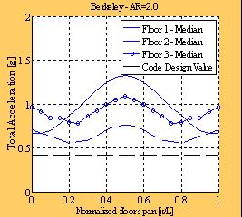
Figure A2-1(b) shows sample results from a suite of 10 earthquake motions for a single set of design parameters (Berkeley DBE, 3-story, perimeter shear wall layout, aspect ratio = 2). Median floor acceleration is plotted along the length of the floor for each story. The current code design value is shown as a straight broken line. For this design case, a Ψ_{D} factor of approximately 1.4 is required to target elastic response for the median response in the DBE for all the diaphragms in the structure.
Figure A2-1. (a) Schematic of RDOF Model; (b) Sample results: Floor acceleration.

3D-FE Analysis: Figure A2-3(a) shows an example of a 3D-FE model for a 3-bay two story parking structure. Spring elements with cyclic characteristics represent the shear and chord reinforcement, described further in Appendix 3, and the plastic hinging in the walls. The effect of secondary elements such as spandrels and their connections are included.
Fig. A2-3(b) shows sample results of chord reinforcement axial, (opening), deformation demand for designs using different Ψ_{D} (OD) factors. A Ψ_{D} =1.0 leads to a maximum (inelastic) chord deformation demand of 0.9in. in the DBE. This value drops to 0.35in. for Ψ_{D} =1.5, and the response is fully elastic for Ψ_{D} =2.0. The MCE demands for the latter two cases are 0.5in. and 0.12in., respectively.

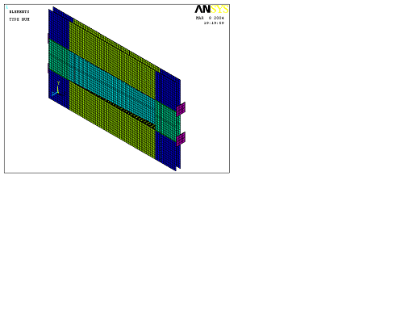
Figure A2-3. (a) Schematic of 3D-FE Model; (b) Sample results: Chord deformation demand.

Such results allow calibration of Ψ_{D} with respect to diaphragm detail classification (LDE, MDE and HDE). Testing has shown that HDE chord details can reliably achieve cyclic tension deformation amplitudes of 0.6in.and that MDE details reliably achieve 0.25in.deformation (See Appendix 4). For this design, the use of Ψ_{D}=1.5 and HDE details is a viable RDO solution. For a BDO solution, Ψ_{D}=2.0 would be required although MDE reinforcement could be used.

Possible Expression for Diaphragm Force Amplification:
The proposed form for the amplification factor is:
$F_{\text{px}}=\frac{w_{\text{dia}}ψ_{\text{vert}}}{μ_{\text{dia}}}F_{x}$
where F_{x} = Story force;
ω_{dia} = Dynamic amplification of diaphragm (depends on story);
ψ_{vert} = Overstrength of vertical LFRS;
μ_{dia} = Ductility capacity of diaphragm as a whole – depends on connections used
For elastic diaphragm design (eg. Short spans, low SDC): μ_{dia} = 1.0

Appendix 3. Determining Appropriate Diaphragm Reinforcement Relative Strength
The methodology uses a capacity design approach to protect specific diaphragm reinforcement groups (Standards New Zealand,1997). The required relative strength of the panel to panel shear reinforcement, and the diaphragm to LFRS anchorage reinforcement, to the chord reinforcement has been found to depend on several factors including diaphragm dimensions and configurations, and diaphragm detailing [Fleischman and Wan, 2007]. The DSDM Project is calibrating the shear and anchorage relative strength factors using two research activities:
- A comprehensive parameter study of precast floor diaphragms using nonlinear static “pushover” analyses of simplified representations of individual diaphragms [Fleischman and Wan,2007].
- A smaller number of 3D-FE nonlinear dynamic transient analyses (NLDTA) of prototype structures to calibrate or verify the findings from the first research activity.

2D-FE Study: Figure A3-1(a) shows a schematic of the 2D diaphragm model used for nonlinear pushover analyses. The parameters that were varied for this model include: (1) Diaphragm span and aspect ratio (AR); (2) Seismic Design Category (SDC); and (3) Diaphragm Detailing Classification.

Figure A3-1(b) shows the diaphragm pushover curves for a single set of diaphragm design parameters (AR=3, L=180’, Charleston) with increasing diaphragm shear reinforcement relative strength Ω_{v}. The greater the Ω_{v} value, the more is the deformation capacity achieved by the diaphragm. A Ω_{v} of 2.15 is needed to develop the full diaphragm flexural strength. However, using less shear reinforcement (Ω_{v} of 1.76 and 1.37), while not preventing shear failure, delays the failure sufficiently to allow some increased inelastic deformation in the diaphragm.. Note that, as indicated in the inserts in Fig. A3-1(b), a chord failure occurs at midspan, while a shear failure occurs at the first panel-to-panel joint ( assuming that Ω_{a} > Ω_{v}). The performance is also characterized by the overall ductility of the diaphragm, μ.

Figure A3-1. (a) Schematic of 2D FE Model; (b) Sample Results: Diaphragm Shear Overstrength Factor Ω_{V}.

Design charts have been constructed using the results of the studies. Fig. A3-2(a) shows, for a given diaphragm geometry, the Ω_{v} values required to achieve specific design targets (diaphragm yield strength, M_{y}: diaphragm ultimate strength, M_{u}; diaphragm ductility ratio, μ; and interstory drift, φ). Likewise, by examining the internal state of the diaphragm, Fig. A3-2b, the required deformation capacity of the diaphragm chord reinforcement, δ_{t,max}, needed to achieve a given design target was determined.

The appropriate design target for a given design is being determined from the second research step: NLDTAs of 3D-FE models of the prototype structures.

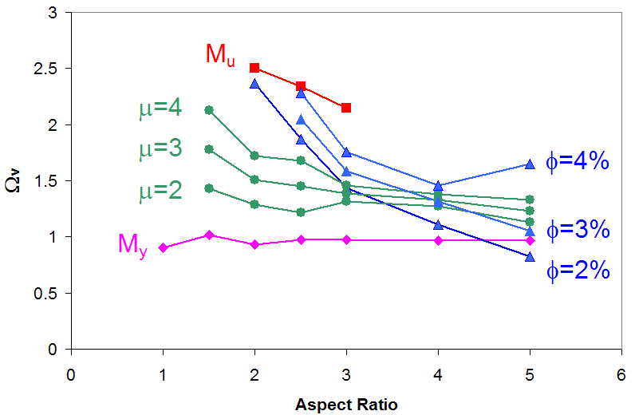
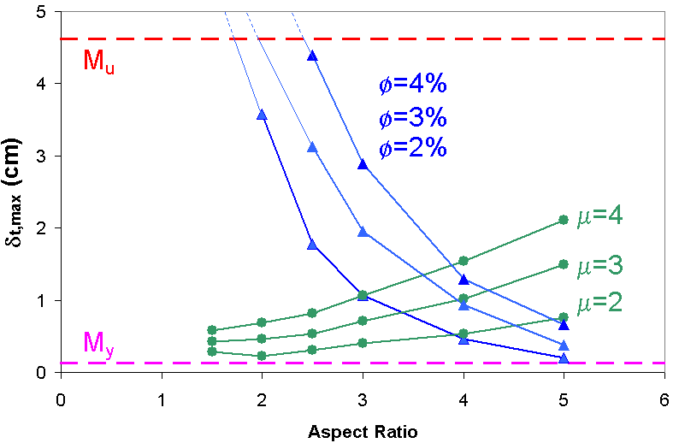
Figure A3-2. Design Charts: (a) Ω_{V} vs. Aspect Ratio; (b) Deformation Capacity vs. Aspect Ratio.

3D-FE Analysis: The 3D FE analyses determine the expected local demands on diaphragm reinforcement crossing diaphragm joints by realistically modeling the connector behavior in finite element models of prototype precast structures. These structures are designed for differing SDCs per current code with requirements adjusted using the diaphragm design factors described in this document. The structures are subject to a suite of ten ground motions scaled to the expected seismic hazard (DBE and MCE) for the design in question.
The finite element models employ discrete coupled springs that represent the shear-tension response of the diaphragm reinforcement crossing the joint. Contact elements are placed in parallel to model the compression zone and friction contributions. The characteristics for the spring elements are obtained from experiments on panels with differing individual diaphragm reinforcement details. Figure A3-3(a) shows a photograph of one of the Lehigh Phase 1 Tests used to determine FE connector model characteristics [Naito et a, 2005l]. Figure A3-3(b) shows a sample test result for a shear connector under cyclic loads and the response of the calibrated spring element adjusted to match the test result.
Figure A3-3. (a) Lehigh Phase 1 Test Specimen; (b) Sample Results: Cyclic Shear Response (Test & FE model) .demand.

Figure A3-4 shows the pushover curve global results (Diaphragm Force vs. Diaphragm Deformation) for an AR=3, L=180’, and the Charleston site for the critical floor from the 3D-FE model (3 story structure, Ψ_{D}=1.5) under the Charleston MCE. As can be seen, this technique allows a target displacement to be determined for the diaphragm for a given set of design parameters. For instance, use of an Ω_{v} =2.15, (shown previously to develop the full flexure strength of the diaphragm), is unnecessary. Instead, an Ω_{v} somewhat greater than 1.4 is sufficient to accommodate the MCE diaphragm demands for this structure.
Figure A3-5 shows how the 3D-FE earthquake simulations are used to calibrate Ω_{v}. . Shown are the response demands for the critical shear connector at the critical shear joint in the diaphragm, (lower insert in Figure A3-4), for a given MCE earthquake. For Fig. A3-5(a), a shear overstrength factor Ω_{v} of 1.1 was used. This value was insufficient to prevent the connector from undergoing shear degradation for this single deterministic evaluation of one structure, one design and one ground motion. Raising the Ω_{v} value to 1.3, Fig. A3-5(b), was sufficient to keep this critical detail elastic throughout the MCE event.
Figure A3-4. Superposition of 3D-FE Global EQ Demand Results on 2D Pushover Curves.

Figure A3-5. Sample Results: Critical Shear Connector, Ψ_{D}=1.5 Berkeley MCE (a) Ω_{v}=1.1, (b) Ω_{v}=1.3. deformation demand.

Appendix 4. Diaphragm Detail Classification and Qualification Procedures
Proper performance of connection details is critical for the effective design and safety of precast concrete building systems. As part of the design methodology a qualification procedure is proposed that provides a systematic approach for assessing the strength and deformation capacity of embedded connections as used in conventional double tee panel systems (Ren and Naito, 2007). In addition a recommendation is provided for categorizing connectors based on measured performance. The recommendation is limited to testing of the in-plane and out-of-plane response of connections. A catalog of connections that have undergone this qualification and classification procedure is being compiled.
The ACI 318 Code that is used for prestressed and non-prestressed concrete construction in the United States provides limited guidance on the design of precast connections. As noted in its Chapter 16, the various components in a connection have different properties, and those properties affect the overall behavior of the connection. Therefore, when a connection is designed using materials with different structural properties, their relative stiffness, strength, and ductility must be considered in evaluating performance.

A ductile flexural mechanism cannot form unless the connection components are designed to ensure that performance. A typical diaphragm connection consists of anchorage bars, welded plate, slug, and slug weld components. The desired connection performance is achieved by the development of a predictable yield mechanism in the anchorage bars and the protection of all other components against premature failure. For example, the weld strength must be not less than the anchorage bar strength.

Scope: The qualification document provides both a testing procedure and a classification framework that establish specific acceptance criteria for in-plane and out-of-plane performance of precast concrete diaphragm connections. For consistency with the emerging design methodology, acceptance criteria are based on prequalification of the deformation capacity. The terminology of low deformability element (LDE), medium deformability element (MDE) and high deformability element (HDE) is used to categorize the response of connections. A procedure for determining the capacity of connectors based on experimental results is described.

Testing Agency: Testing is to be performed by a recognized independent testing agency. That testing and reporting must be supervised by a professional engineer familiar with the proposed design procedure and experienced in testing and seismic structural design.

Test Modules: A minimum of two modules should be tested for each characteristic connection configuration in the prototype diaphragm. Connections are to be tested full scale unless both connections and modules have a scale large enough to represent fully the complexities and behavior of the real materials and of the load transfer mechanisms in the prototype diaphragm. For modules that are to be subjected to loadings that include in-plane loadings there must be at least two connections per module.

Reference Deformation: For each connection type, a monotonic test to failure must first be conducted to obtain a reference deformation used in subsequent cyclic tests. This reference deformation characterizes the effective yield deformation of the connection. That deformation is the deformation corresponding to the maximum load on a secant stiffness line drawn through the load and deformation for 75% of the maximum load.

In-plane Displacement Based Protocols: The modules are to be loaded under in-plane pure shear, pure tension, shear combined with tension and out-of-plane shear. Tests are to be conducted under displacement control at quasi-static rates (< 0.05in/sec) and force control. The specified testing sequence for cyclic loading is shown in Figure A4-3 where at a ductility ratio of 1.0 the applied displacement is equal to the reference deformation.

Data Acquisition: Data shall be recorded from the test such that a quantitative, as opposed to qualitative, interpretation can be made of the performance of the test module. A continuous record shall be made of the force versus deformation. For in-plane tests the axial and shear forces and the deformations transverse and parallel to the joint are recorded. For out-of-plane tests the vertical force and deformation are recorded. For static testing, data are recorded at a rate of 1.0 cycle/second.

Test Observations: Photographs must be taken that show the condition of the test module at the completion of testing as well as significant points throughout the testing history. Ideally photos should be taken at the end of each group of cycles. Photos taken at points of interest, such as first cracking, yield, ultimate load and post-test, are adequate for most evaluations.

Test Report: The test report must be sufficiently complete and self-contained for a qualified expert to be satisfied that the tests have been designed and conducted in accordance with the required criteria, and that the results satisfy the intent of the qualification document.
The test report must contain sufficient evidence for an independent evaluation of the performance of each test module. As a minimum, all of the following information is needed:
S.1-A description of the theory used to predict test module strength and deformation
S.2- Details of test module design and construction, including engineering drawings.
S.3-Specified materials properties used for design, and actual material properties obtained by testing.
S.4- Description of test setup, including panel details and photographs.
S.5- Description of instrumentation, location, and purpose.
S.6- Description and graphical presentation of applied loading protocol.
S.7- Description of observed performance, including photographic documentation, of test module condition at key loading cycles.
S.8- Graphical presentation of force versus deformation response.
S.9-Test data, report data, name of testing agency, report author(s), supervising professional engineer, and test sponsor.

Acceptance Criteria: Based on the requirements in FEMA 356 and ASCE/SEI 41-06, each component is classified as a primary or secondary element or component prior to the development of component acceptance criteria and the intended response of each connection is classified as deformation-controlled (ductile) or force-controlled (non-ductile). It is assumed that the connection represents a primary component of the structural system and that all actions applied to the connection can be classified as deformation-controlled or force-controlled.

As depicted in Fig. A4-1 taken from ASCE/SEI 41-06, Type 1 and Type 2 responses are representative of ductile behavior. There is an elastic range (point 0 to point 1) followed by a plastic range (point 1 to point 3). Type 3 response is representative of a brittle or non-ductile behavior. There is an elastic range (point 0 to point 1) followed by a loss of strength.

If connections display the Type 1 or Type 2 response and have Δ_{e} >2Δ_{g}, they are classified as deformation-controlled; otherwise, they are classified as force-controlled. If connections display the Type 3 response, they are classified as force-controlled.

Figure A4-1. Connection Classification per ASCE/SEI 41-06 Procedures

Deformability Category: Based on the experimental data collected to date, and finite element analyses of diaphragms with differing sizes and differing configurations subject to differing earthquake records, the typical required tension opening, d_{t}, and shear displacement, d_{v}, values for deformability categorization are as shown in Table A4-1. The typical required ductility demands,μ, and joint rotation demands, φ, obtained from finite element analysis for diaphragms of differing sizes subject to differing earthquake records are shown in Fig. A4-2. That figure illustrates how the information gained through the activities described in Appendix 3 are combined with the classification system described in this Appendix. The results of Fig. A4-2 are based on the data shown in Fig. A3-2, cross-referenced to the requirements of the deformability categories.

Table A4-1 Typical Values for Deformability Categorization
Deformability Category | Tension deformation d_{t} [in] | Shear deformation d_{v} [in]
Low deformability | 0.00<d≤0.15 | 0.00<d≤0.30
Med. deformability | 0.15<d≤0.50 | 0.30<d≤0.70
High deformability | d>0.50 | d>0.70

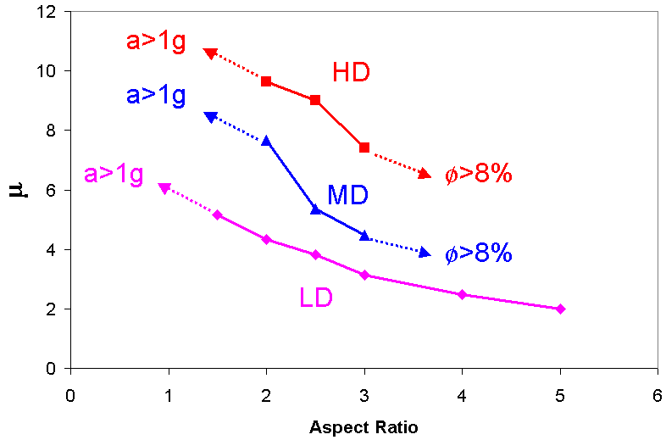
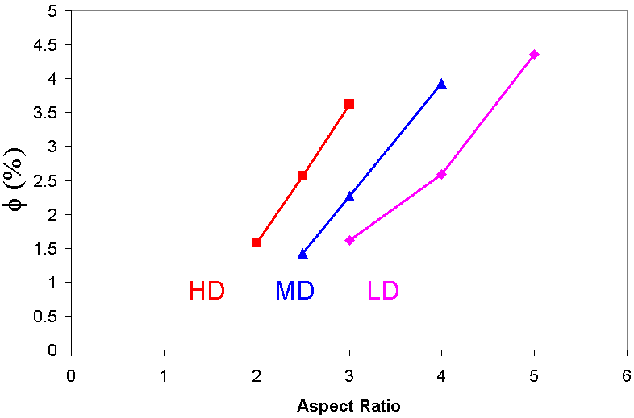

Figure 4-2 Component Response Classification

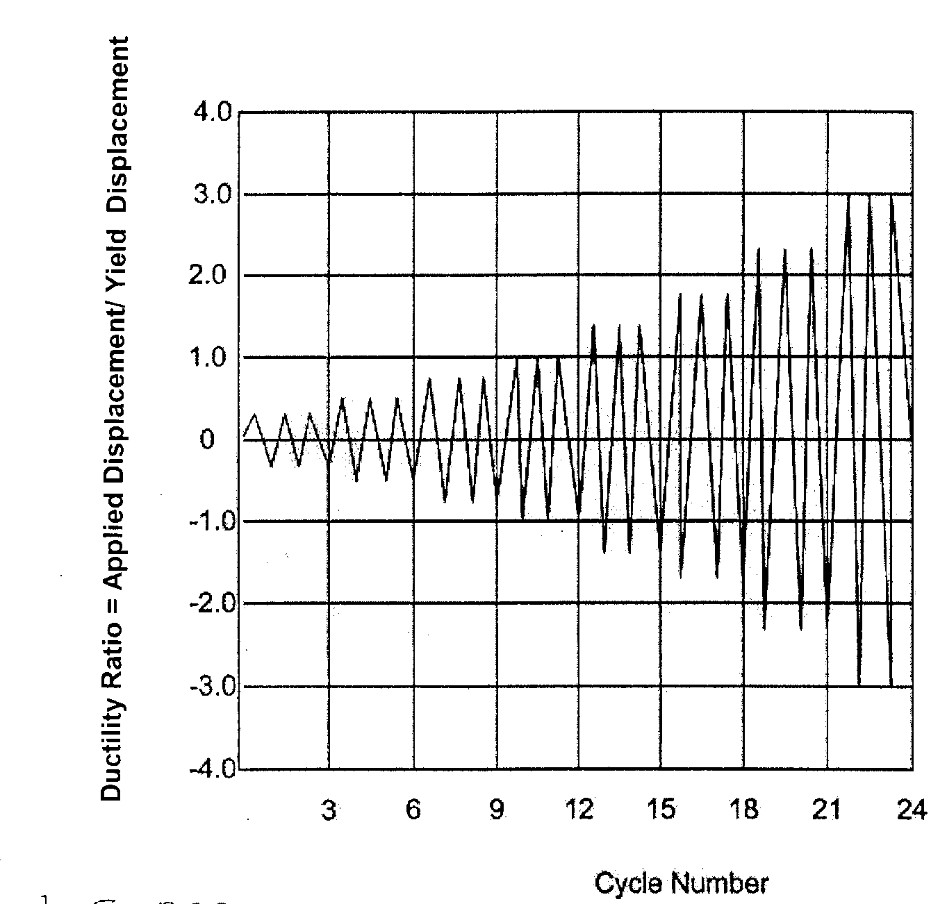

Figure A4-3 Example of Specified Test Sequence

Appendix 5. Diaphragm Strength and Stiffness Calculations
Several methods have been proposed for calculating the stiffness of a precast concrete diaphragm ( Zheng and Oliva, 2005; Farrow and Fleischman, 2003; Nakaki,2000). The methodology uses the spreadsheet-compatible method, developed by Wan and Fleischman, 2007a, that has similarities to the prior approaches.

The spreadsheet method is used to: (1) Calculate the elastic stiffness of the precast diaphragm in terms of equivalent elastic modulus and shear modulus; and (2) Calculate the flexural yield strength of the precast diaphragm including any contributions from the shear reinforcement to that strength. The calculation is based on a rational method, and is used in the proposed design methodology to: (1) Either manually determine the diaphragm deflection or conveniently model the floors in design software; and (2) Determine the nominal strength of the diaphragm for comparison to the design moment M_{u} caused by Ψ_{D}F_{px}. The method is calibrated by comparisons to finite element analyses of diaphragms with differing geometries and reinforcing details.

The method uses the following assumptions:
- Plane sections remain plane at joints between precast units.
- Concrete in the precast unit is linear elastic and uncracked and the slab thickness is constant (i.e., contributions of washes and curbs in parking garage floors are ignored).
- Reinforcement in the diaphragm compression zone is ignored in determining compression stiffness (i.e., deformation is based on precast concrete unit only).
- The same number and type of shear connectors are used at all joints in the diaphragm and are evenly distributed along the length of the joint.
- Shear reinforcement is assumed to respond elastically at diaphragm yield, in accordance with the proposed design methodology (Fleischman et al., 2005a).

The method assumes initial positions for the neutral axis and center of compression, and calculates an effective flexural stiffness of the joint based on those positions and the elastic stiffness of the discrete diaphragm reinforcing elements. This value is combined with the elastic stiffness of the panel to create an overall flexural rigidity, and finally E_{eff}. Shear stiffness of the joint and the panels are calculated and combined in a similar manner to find an effective diaphragm shear modulus G_{eff}. A similar approach is used to find the diaphragm moment strength except that: (1) Discrete strengths are used instead of discrete stiffnesses; and (2) A different formulation is used to determine the position of the neutral axis at yield than in the elastic state.

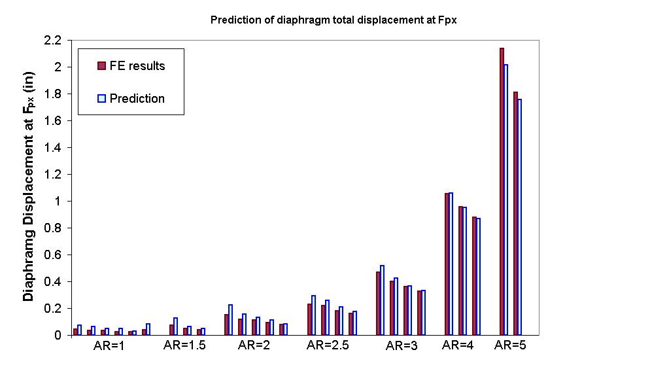
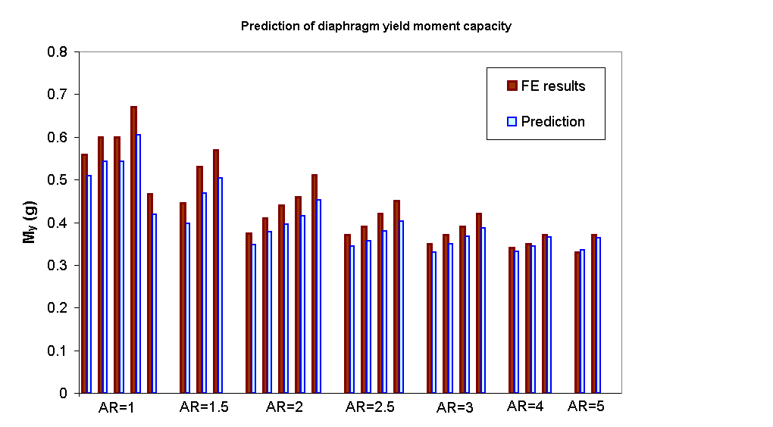
Figure A5-1(a) compares the stiffness calculated by this method with that determined from FEM analyses (Wan and Fleischman, 2007a) . Figure A4-1(b) shows the same comparison for strength [Wan]. The method shows reasonable agreement with FEM results. In addition the methods are being calibrated using experimental results from the hybrid panel tests and will be further validated in the half-scale shake table
Figure A5-1. Comparison with FE analysis: (a) Diaphragm Stiffness; (b) Yield Strength.

Appendix 6. Diaphragm Load Path
Several methods exist for determining diaphragm internal load paths that are alternates to the horizontal beam approach. For example, strut and tie methods, are used outside the U.S. [fib, 2003]. The design methodology maintains the horizontal beam approach, but recognizes alternate methods may be useful and provides for use of those methods.

The design methodology imposes structural integrity requirements. Required are: (1) Adequate anchorage of diaphragms to the primary LFRS elements, including the carrying of superimposed gravity loads and accommodating imposed rotations from walls [Menegotto, 2000]; (2) Maintenance of seating for the precast units [Mejia-McMaster and Park,1994]; and (3) Provision of minimum ductility requirements for joint reinforcing details. An important component of the structural integrity measures is also the treatment of secondary members such as spandrels (See Fig. A6-1 where the spandrel is SP). The effect of the spandrel, for instance as shown in Fig. A6-2, has been quantified through analytical studies [Wan and Fleischman, 2007b].

(a) High shear region (b) High flexure region
Leading SP
Free Body Diagram (Forces in SP longitudinal direction removed for clarity)
Forces in DT-SP connectors
Precast units
Trailing SP
Shear wall
0
1
Uncovered joint not at max shear
0
1
3
3:
Inertial force
L_{sp}
Confining effect within SP span due to opening
Leading SP
Trailing SP
Precast units
Concentrated Opening
Limited Opening
Free Body Diagram (Forces in SP transverse direction removed for clarity)
Figure A6-1: Schematics of Interaction Between Spandrels and Precast Floor Units.
(a) Joint sliding (b) Joint opening
Figure A6-2: Joint Deformation Profiles Including Spandrel Effects: (a) Sliding; (b) Opening.

References

ACI Committee 318, 2008 “Building Code Requirements for Structural Concrete (ACI 318-08) and Commentary (ACI R318-08)”, American Concrete Institute, Farmington Hills, MI
American Society of Civil Engineers, 2007, “Seismic Rehabilitation of Existing Buildings, ASCE Standard ASCE/SEI 41-06”, Reston, VA.

Building Seismic Safety Council, (BSSC 2000), “NEHRP Recommended Provisions for Seismic Regulations for New Buildings and Other Structures, FEMA 369 (Commentary)”, Federal Emergency Management Agency, Washington, DC, 2000.

DSDM, 2006, Year 2 Report to National Science Foundation, (NSF) GOALI Project “Development of a Precast Floor Diaphragm Seismic Design Methodology (DSDM)”, Aug 17, 2006.

Eberhard, M. O. and Sozen, M. A., 1993, “Behavior-Based Method to Determine Design Shear in Earthquake-Resistant Walls”, American Society of Civil Engineers, Journal of Structural Engineering, 119 (2), 619-640.

Earthquake Engineering Research Institute (EERI), 1994, Northridge Earthquake, January 17, 1994, Preliminary Reconnaissance Report, Oakland, CA.

Farrow, K. T., and Fleischman, R. B., 2003, “Effect of Dimension and Construction Detail on the Capacity of Diaphragms in Precast Parking Structures,” PCI JOURNAL, V. 48, No. 5, Sept.-Oct., pp. 46-61.

Federal Emergency Management Agency, 2000 “NEHRP Commentary on the Guidelines for the Seismic Rehabilitation of Buildings”, Nov.

FIB, 2003, “State-of-the-Art Report on the Seismic Design of Precast Concrete Building Structures,” Commission 7 Task Group, Fédération Internationale du Béton, Lausanne, Switzerland, Robert Park (Editor), Sprint-Digital-Druck, Stuttgart, Germany, October 2003.

Fleischman, R. B. and Wan G., 2007, “Appropriate Overstrength of Shear Reinforcement in Precast Concrete Diaphragms”, ASCE J. Struct. Engrg., Special Issue: Precast/Prestressed Concrete Structures under Natural and Human-Made Hazards, Vol. 133, Issue 11, pp. 1616-26, Nov., Y. Kurama Ed.

Fleischman, R. B., Naito C.J., Restrepo J., Sause R. and Ghosh S.K., 2005a, “Seismic Design Methodology for Precast Concrete Diaphragms, Part 1: Design Framework”, PCI Journal, V. 50, No 5, Sept.-Oct. pp. 68-83.

Fleischman R.B., Naito C.J., Restrepo J., Sause R., Ghosh S.K., Wan G., Schoettler M. and Cao L., 2005b, "Seismic Design Methodology for Precast Concrete Diaphragms, Part 2: Research Program", PCI Journal, V. 51, No. 6, Nov.-Dec. pp. 2-19.

Fleischman, R. B., and Farrow, K. T., 2003, “Seismic Design Recommendations for Precast Concrete Diaphragms in Long Floor Span Construction,” PCI Journal, V.48, No.6, Nov-Dec.,pp. 46-62.

Fleischman, R. B., Farrow, K. T. and Eastman, K.,2002, “Seismic Performance of Perimeter Lateral-System Structures with Highly Flexural Diaphragms”, Earthquake Spectra, V. 18, No. 2, May, Earthquake Engineering Research Institute, Oakland, CA.

Fleischman, R. B. and Farrow, K. T., 2001, “Dynamic Response of Perimeter Lateral-System Structures with Flexible Diaphragms, Earthquake Engineering and Structural Dynamics, 30 (5), 745-763.

Fleischman, R. B., Sause, R., Pessiki, S., and Rhodes, A. B., 1998, “Seismic Behavior of Precast Parking Structure Diaphragms”, PCI Journal, V.43, No.1, Jan.-Feb. pp. 38-53.

Fleischman, R. B., Sause, R., Rhodes, A. B., and Pessiki, S., 1996, “Seismic Behavior of Precast Parking Structure Diaphragms’, Proceedings, XIV ASCE Structures Congress, Building an International Community of Structural Engineers, S. K. Ghosh Ed., V. 2, Chicago, IL, April 15-18, pp. 1139-1146.

Hall, J. F. (Editor), 1995, “Northridge Earthquake Reconnaissance Report,” Earthquake Spectra, V. 11, Supplement C, No. 1, Sept.-Oct., p. 523.

Hawkins, Neil M., and Ghosh, S. K., 2000 "Proposed Revisions to 1997 NEHRP Recommended Provisions for Seismic Regulations for Precast Concrete Structures: Part 3 – Diaphragms," PCI Journal, Vol. 45, No. 6, Nov.-Dec.

IBC, International Building Code, 2006 Edition, International Code Council, Inc., Falls Church, VA.

Iverson, J. K., and Hawkins, N. M., 1994, “Performance of Precast/Prestressed Concrete Building Structures During Northridge Earthquake,” PCI Journal, V. 39, No. 2, Mar.-Apr., pp. 38-55.

Ju, SH, and Lin, MC. 1999, “Comparison of Building Analyses Assuming Rigid or Flexible Floors,” ASCE Journal of Structural Engineering V.125 No.25.

Kao, G., 1998, “Design and Shake-Table Tests of a Four-Storey Miniature Structure Built with Replaceable Plastic Hinges”, M.E. Thesis, Dept. of Civil Engineering, University of Canterbury, Christchurch, NZ.

Lee, H.J., and Kuchma, D.A., 2007, “Seismic Overstrength of Shear Walls in Parking Structures with Flexible Diaphragms,” Journal of Earthquake Engineering, V.11, No.1 Jan., pp. 86-109.

Lee, H.J., Kuchma, D.A., and Aschheim, M.A.,2008, “Strength–Based Design of Flexible Diaphragms in Low-Rise Structures Subject to Earthquake Loading,” Engineering Structures (In Press).

Lee, H.J., Aschheim, M.A., and Kuchma, D., 2008, “Interstory Drift Estimates for Low-Rise Flexible Diaphragm Structures,” Engineering Structures (In Press).

Mejia-McMaster, J. C., and Park, R., 1994, “Tests on Special Reinforcement for End Support of Hollow-Core Slabs,” PCI Journal, V. 39, No. 5, Sept.-Oct., pp. 90-105.
Menegotto, M., 2000, “Precast Floors Under Seismic Action,” Proceedings, The Second International Symposium on Prefabrication—Helsinki, Finland, May 2000.
Naito, C., Cao, L., 2004, “Precast Diaphragm Panel Joint Connector Performance,” Paper 2722, Proceedings, 13th World Conference on Earthquake Engineering, Vancouver, Canada
Naito, C., Peter, W., and Cao, L., 2006, “ Development of a Seismic Design Methodology for Precast Diaphragms, Phase 1 Summary Report”, ATLSS Report No. 06-03, Lehigh University, Bethlehem, PA, Jan.

Nakaki, S. D., 2000, Design Guidelines for Precast and Cast-in-Place Concrete Diaphragms,” 1998 NEHRP Professional Fellowship Report, Earthquake Engineering Research Institute, April.

Oliva M.G., 2000, “Testing of the JVI Flange Connector for Precast Concrete Double-Tee Systems,” Structures and Materials Test Laboratory, College of Engineering, University of Wisconsin, June.

Pincheira, J.A., Oliva, M.G., and Zheng, W., 2005, “Behavior of Double-Tee Flange Connectors Subjected to In-Plane Monotonic and Reversed Cyclic Loads,” PCI Journal, V.50, No.6, Nov.-Dec., pp. 32-54.

Ren, R., and Naito, C.J., 2007, "Acceptance Criteria for Precast Concrete Diaphragm Connectors Based on Structural Testing ", ATLSS Report # 07-XX, Lehigh University, Sept.

Rodriguez, M. E., Restrepo, J. I., and Carr, A. J., 2001, Earthquake Induced Floor Horizontal Accelerations in Buildings”, Earthquake Engineering and Structural Dynamics. V.31.

Shaikh A.F. and Feile E.P.,2004, “Load Testing of a Precast Concrete Double Tee Flange Connector”, PCI Journal, V.49, No.3, 49 May-June, pp. 84-94.

Standards New Zealand, 1997 “Concrete Structures Standard—The Design of Concrete Structures” and “Commentary on the Design of Concrete Structures,” NZS 3101: Parts 1 and 2:1995 and “Amendment No. 1 to NZS 3101, 1997,” Wellington, New Zealand.

Tena-Colunga, A. and Abrams, D. P., 1992, Response of an Unreinforced Masonry Building During the Loma Prieta Earthquake”, Structural Research Series No. 576, Department of Civil Engineering, University of Illinois at Urbana-Champaign.

Wan, G. and Fleischman, R.B., 2007a, “A Rational Method for Calculating the Service Stiffness and Yield Strength of Precast Floor Diaphragms”, in preparation.

Wan, G. and Fleischman, R. B., 2007b. “Effect of Spandrel Beam to Double Tee Connection Characteristic on Precast Diaphragm Response”, in preparation.

Wood, S. L., Stanton, J. F., and Hawkins, N. M., 2000, “New Seismic Design Provisions for Diaphragms in Precast Concrete Parking Structures,” PCI Journal, V. 45, No. 1, Jan.-Feb., pp. 50-65.

Wood, S. L., Stanton, J. F., and Hawkins, N. M., 1995, “Performance of Precast Parking Garages During the 1994 Northridge earthquake, Proceedings, XIII ASCE Structures Congress, Restructuring: America and Beyond, 1, New York, NY, pp. 563-566.

Zheng, W., and Oliva, M.O. 2005, “A Practical Method to Estimate Elastic Deformation of Precast Pretopped Double Tee Diaphragms”, PCI Journal V.50, No.2, March-April, pp.44-55.

For squat shear walls, use R=1.

